iOS – QC1227 – Reg Check – Pending Revision Inputter screen display

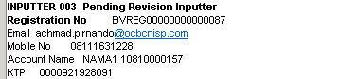

Inputter – 003 – pending revision – **NO Revision Ticket Number**

Registration No – BVREG00000000000087

Email: [achmad.pirnando@ocbcnisp.com](mailto:achmad.pirnando@ocbcnisp.com)

Mobile: 08111631228

Acct Name: NAMA1 10810000157

KTP: 0000921928091

Expected Result:

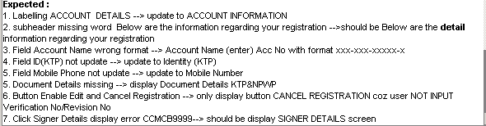

1. Labeling ACCOUNT DETAILS 🡪 ACCOUNT INFORMATION

2. Sub header missing word: Below are the information regarding your registration 🡪 Below are the details information regarding your registration. (This is good)

3. Acc Number format (under account Name) --> xxx-xxx-xxxxx-x

4. Field ID (KTP) not update 🡪 Identity (KTP)

5. Field Mobile Phone not update 🡪 Mobile Number

6. Document Details missing 🡪 display Document details KTP&NPWP

7. Button Enable Edit and Cancel Registration 🡪 Only display button CANCEL REGISTRATION cos user did not input Verification Code. --- BE --- is fixing to check on revision number when that is empty in order to determine the return of allow_Cancel = Y

8. Click Signer Details display error CCMB.9999997 🡪 should display Signer Details Screen. - (this is good for now.)