iOS – QC1228 – Registration Check – Pending Revision Signer Screen

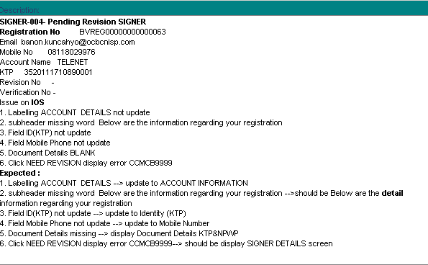

Signer-004-Pending Revision - NO REVISION NUMBER INPUT

Registration No.: BVREG00000000000063

Acct Name: TELENET

e-Mail : banon.kuncahyo@ocbcnisp.com

MOBILE NO : 08118029976

KTP : 3520111710890001

Expected:

1. Labelling Account Details 🡪 ACCOUNT INFORMATION
2. Subheader missing (under Signer Details) 🡪 Below are the details information regarding your registration
3. Field ID (KTP) 🡪 Identity (KTP)
4. Field Mobile Phone 🡪 Mobile Number
5. Document Details 🡪 KTP & NPWP
6. Clicked NEED REVISION display error CCMB.9999997 🡪 should be Signer Details screen. (NOT an issue)