iOS – QC1223 – Registration Check - Copywriting issues

Login page different display ios :

1. button display REGISTRATION CHECK/ CEK REGISTRASI

2. Please take out labelling of Terms and Condition

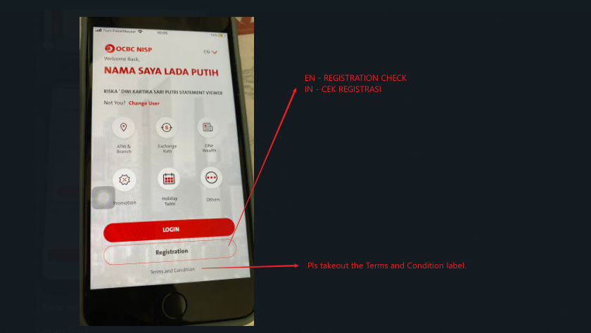

2021.09.22

Please use CAPITAL letter for IOS: REGISTRATION CHECK/ CEK REGISTRASI

