Android - QC1227 - Registration Check - Force close

1. Android - should have displayed only cancel button. (checked log)

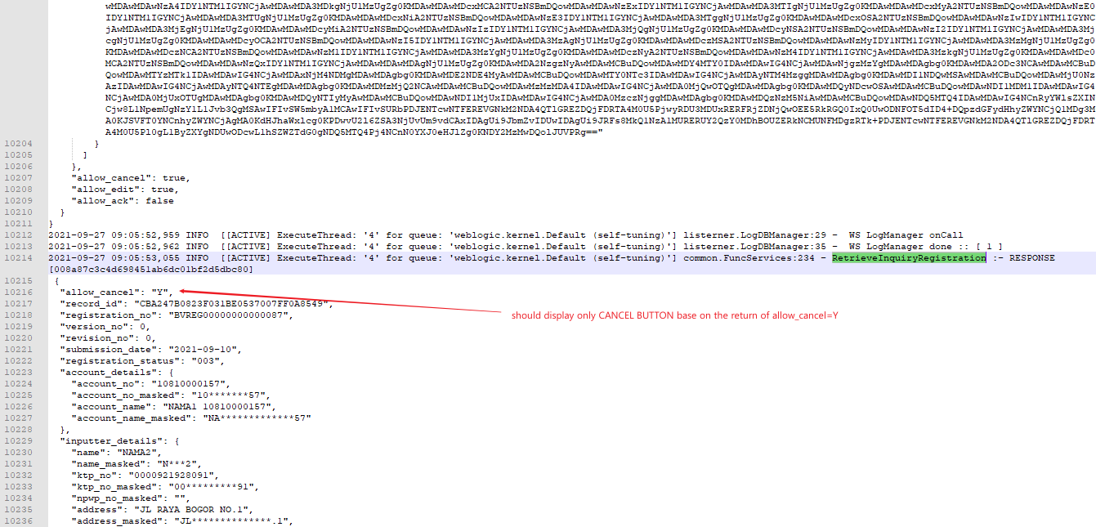

2. Unable to display Signer Details - hitting no server/ internet connection

- when I retested by 10:01, force closed then clicking check button again - hit MCB9999999

3. Please display copywriting under Status of Pending Revision (same with iOS) - Please check your registered email for details on the needed revision

