iOS - Registration Check - Sequence parameter needed for Acknowledgement Submission

Please include "Sequence" parameter in the request of RegistrationAckSubmit.

Current:

Missing "Sequence" parameter during RegistrationAckSubmit WS in the request to BE.

Expected:

FE: Sequence parameter needs to be sent to BE during RegistrationAckSubmit WS.

- May get the "sequence" from RetrieveInquiryRegistration Response from BE.

- Under Signer List - Sequence (Please take this)

Changes as below:

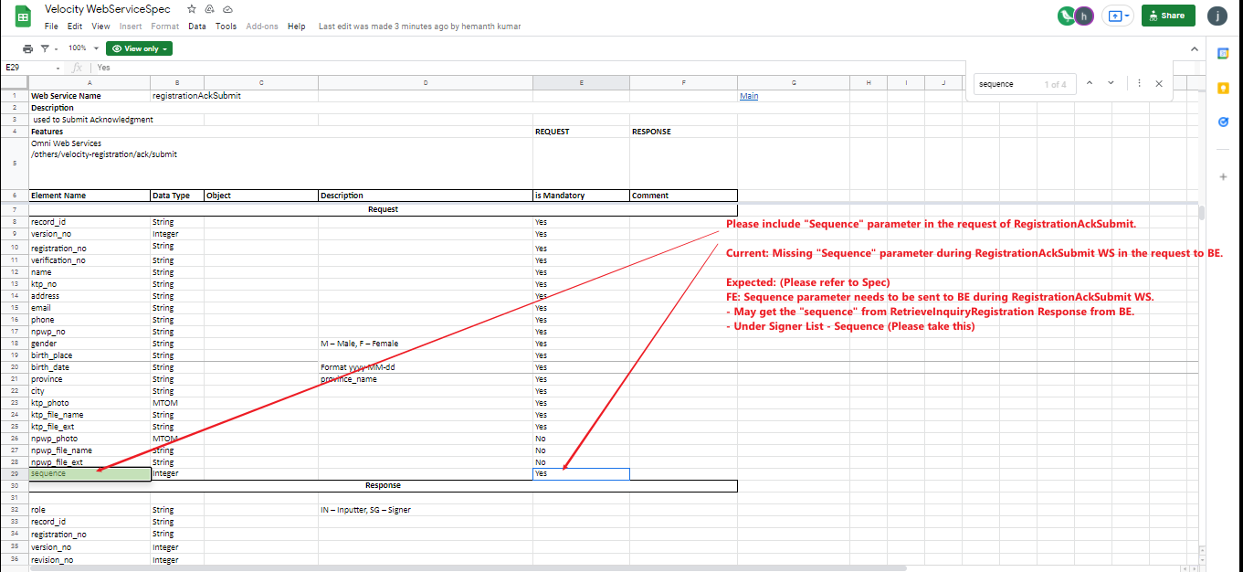

Current issue:

