**TRANSACTIONS – FUND TRANSFER – OCBC NISP FUND TRANSFER, DOMESTIC TRANSFER, TELEGRAPHIC TRANSFER**

After Remarks field, add a new field with maximum characters are 1000:

**ENG 🡪 Additional Remarks (maximum 1000 characters)**

**IND 🡪 Keterangan Tambahan (maksimum 1000 karakter)**

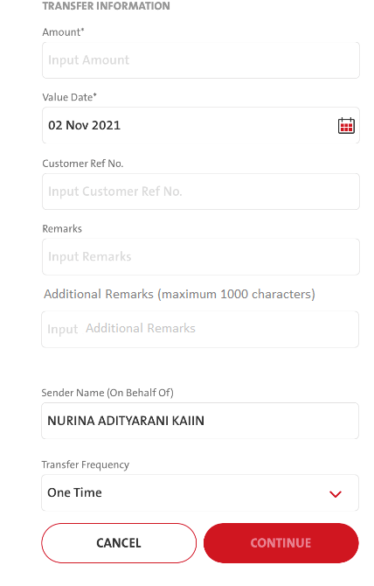

**TRANSACTIONS – TRANSACTION SUMMARY – MANUAL – VIEW RECEIPT – DOWNLOAD RECEIPT**

**TRANSACTIONS – TRANSACTION SUMMARY – NON BULK FILE UPLOAD – VIEW TRANSACTIONS - VIEW RECEIPT – DOWNLOAD RECEIPT**

If the transaction types are Internal Fund Transfer, Own Fund Transfer, LLG/SKN, RTGS, Online Transfer, and Telegraphic Transfer, add a check box on the DOWNLOAD OPTION window:

**ENG 🡪 Include Additional Remarks**

**IND 🡪 Tampilkan Keterangan Tambahan**

