Category code 3, Credit Services is disabled

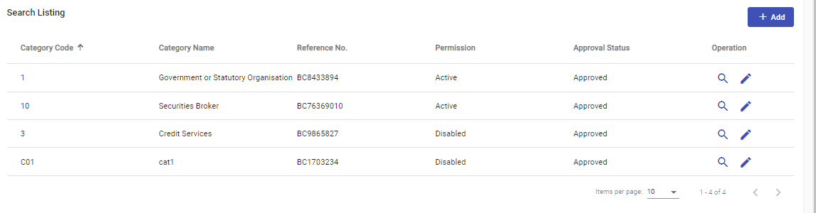

Able to add Promise (HK) Co Ltd

