Bank Transaction Reference in the file



Unique Reference Number in Backoffice

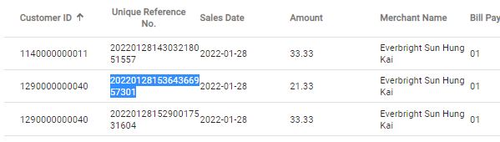

The reason of using this is because the available length in EPS file is 60 and this field is mainly use for our end matching purpose.

Bill Payment Type is missing in the file



The Bill payment record is having “01” as bill payment type

