Menu: Transactions – Payment & Purchase
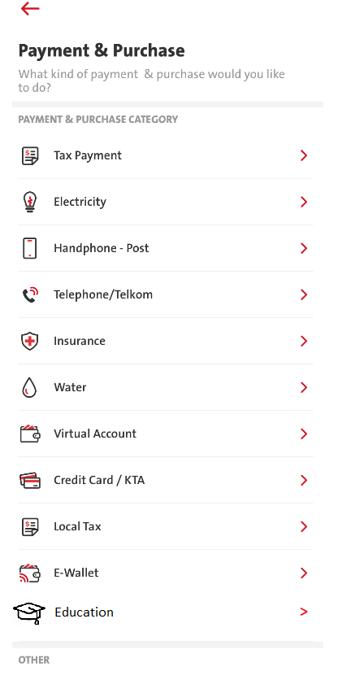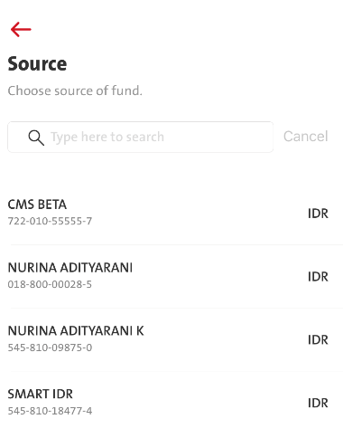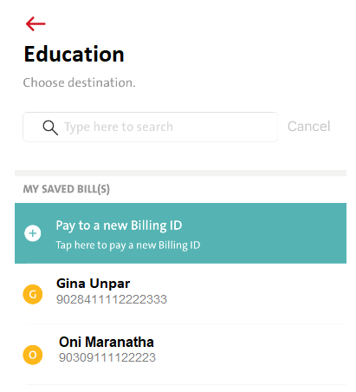
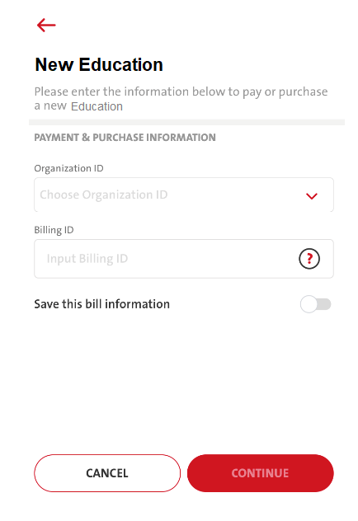
Follow all existing process (confirmation – token – acknowledgement, etc)
RULES
- Organization ID consists of UNPAR BDG, UNPAR – SPP, UNPAR UP, MARANATHA
- Billing ID Pop Up Info sample:
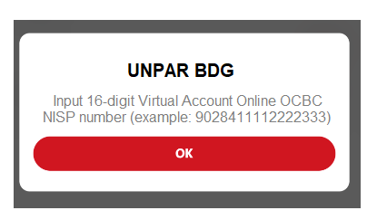

COPYWRITING
No | ENG | ID
1 | Education | Pendidikan
2 | New Education | Pendidikan Baru
3 | Please enter the information below to pay or purchase a new Education | Masukkan informasi di bawah ini untuk membayar atau membeli Pendidikan baru
 | Pop Up Billing Info
4 | UNPAR BDG  Input 16-digit Virtual Account Online OCBC NISP number (example: 9028411112222333) | UNPAR BDG  Masukkan 16 digit nomor Virtual Account OCBC NISP (contoh: 9028411112222333)
5 | UNPAR – SPP  Input 16-digit Virtual Account Online OCBC NISP number (example: 9028511112222333) | UNPAR - SPP  Masukkan 16 digit nomor Virtual Account OCBC NISP (contoh: 9028511112222333)
6 | UNPAR UP  Input 16-digit Virtual Account Online OCBC NISP number (example: 9028211112222333) | UNPAR UP  Masukkan 16 digit nomor Virtual Account OCBC NISP (contoh: 9028211112222333)
7 | MARANATHA  Input 14-digit Virtual Account Online OCBC NISP number (example: 90309111122223) | MARANATHA  Masukkan 14 digit nomor Virtual Account OCBC NISP (contoh: 90309111122223)

