1. Having H,D,T starting of Header, Detail and Trailer. Base on spec, it doesn’t have.

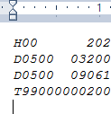

2. For FTU-ACCT-No, need to pass in card token instead of Bill Account Number.

Example: 03200213 is Bill Account Number, should put card token.

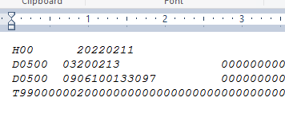

3. FTU-MERCH-NAME + FTU-MERCH-CITY + FTU-MERCH-STATE total have 41 characters but in the file the length only got 40.

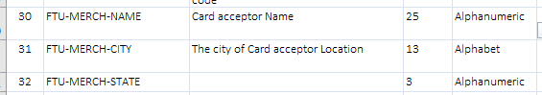



4. SR-AMT-ORIGINALS in Trailer is displaying “00000000008”, the summary amount should be more than this.

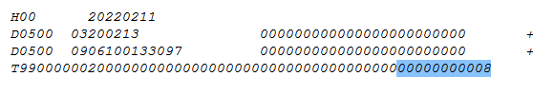

5. SR-HEADER-TRAILER-SEQ in Trailer, if not mistaken need to set as “ 1” instead of “1 “.



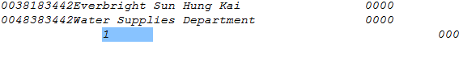

6. For record that pay to Everbright Sun Hung Kai, the charges is 0.76 HKD. Need to create another settlement record with amount 0.76HKD with FTU-TRAN-CODE-SUB = 15.