For BC24623311, it is Merchant, not Merchant Category



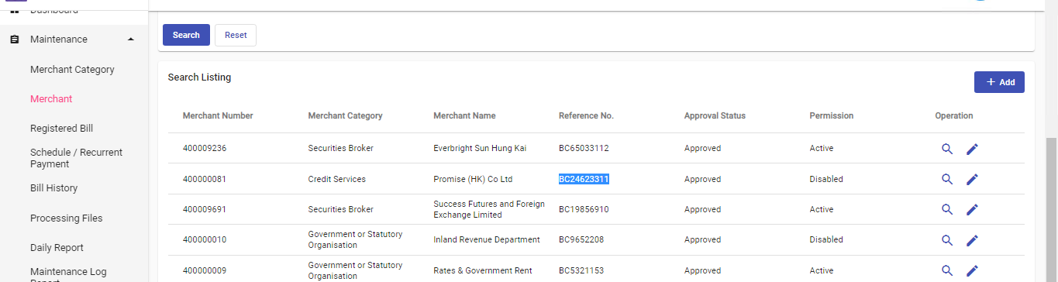

For Merchant, Merchant category is not display in report.

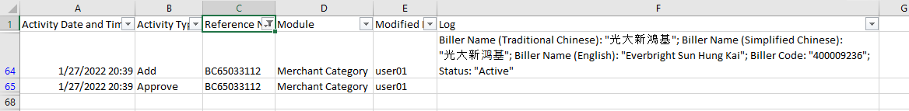

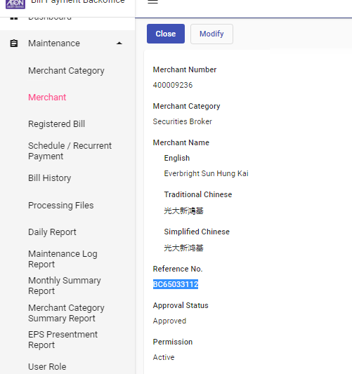

For Merchant Bill, some fields are not display in report.

Account Description (EN, Simplified and Traditional Chinese), min amount, max amount, charge type, charge amount, daily payment count,

