1. Tested good

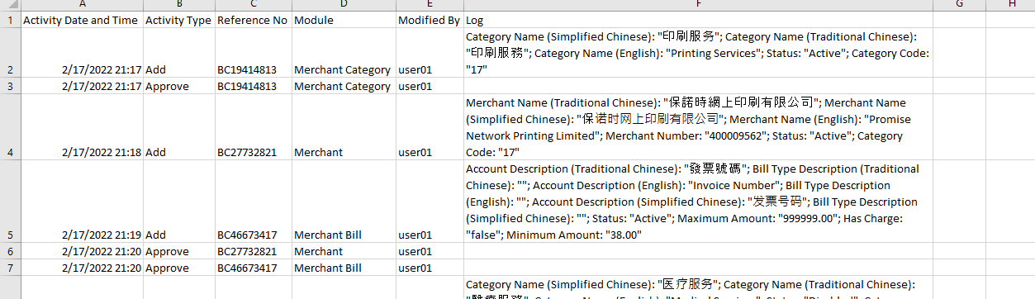

2. Tested good

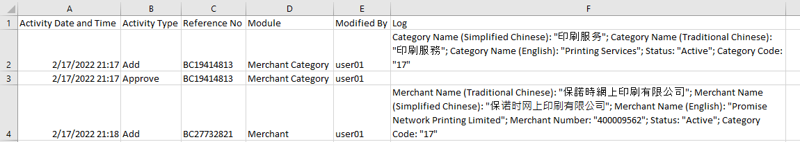

3. Tested good

