Transaction on 16 Feb 2022

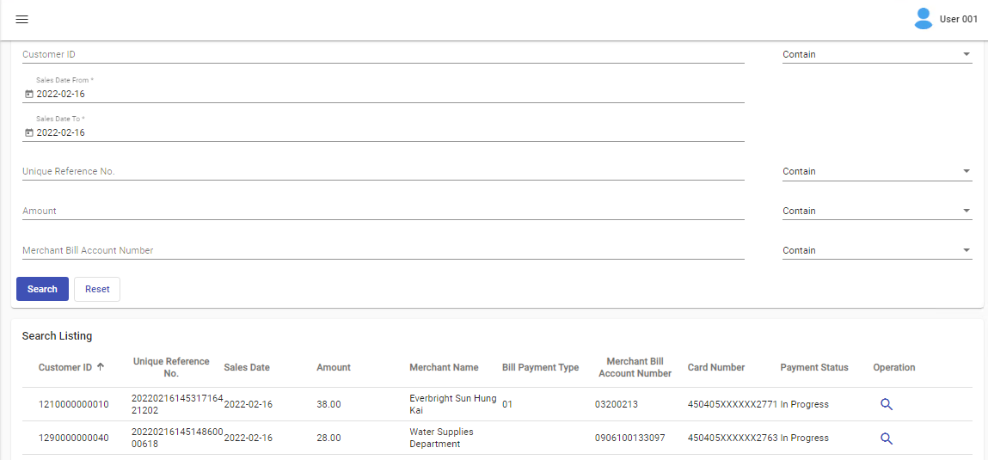

Both Transactions appeared in report

