1. Daily report file naming can it base on Transaction Date in Search Criteria? Currently when I use 18 Feb, will generate file naming base on today’s date.

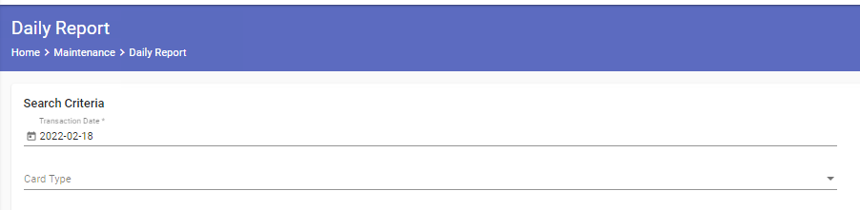



2. Please help to map authorization date as payment date.

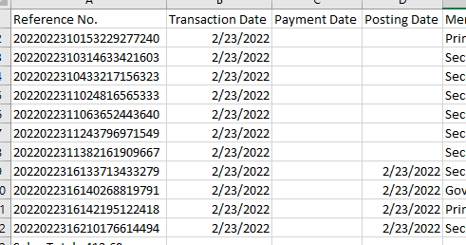

3. The payment already changed to completed, but in daily report, it is showing in progress. The sample report is with date 23 Feb 2022.

