1. Search Criteria set to feb 2022 to feb 2022, but report showing jan and feb 2022. Should only show feb 2022

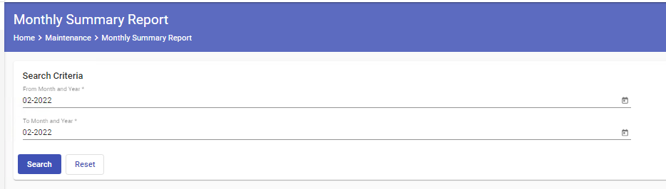

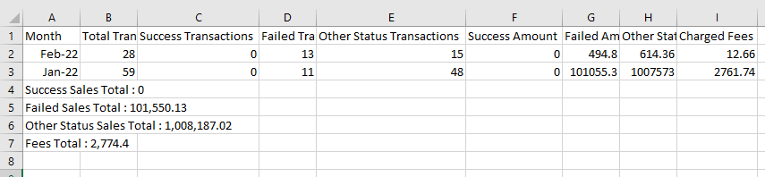

2. There are some transactions already success and posted, but success amount in both monthly report and merchant category summary report are showing 0.

Monthly Report



Merchant category report that generates using date 23 feb 2022 to 23 feb 2022.

