Previously in Settlement file, this field is having 00, but settlement file generated on 23 Feb is showing 0. Please change to show 00 based on the spec.

Previous file

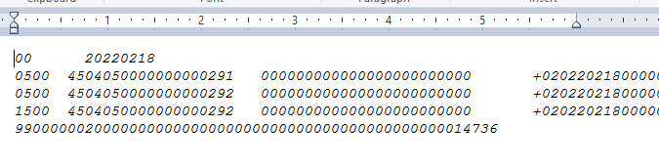

Current file

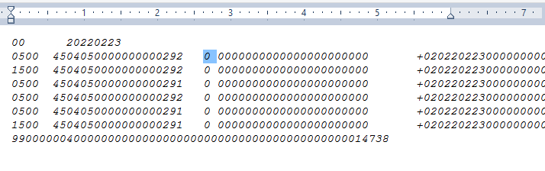

Spec

