**Action:** Send another scheduler job before receiving response file from EPS on previous request

**Scenario 1:** Resend with no additional list

**Result:** No file generated

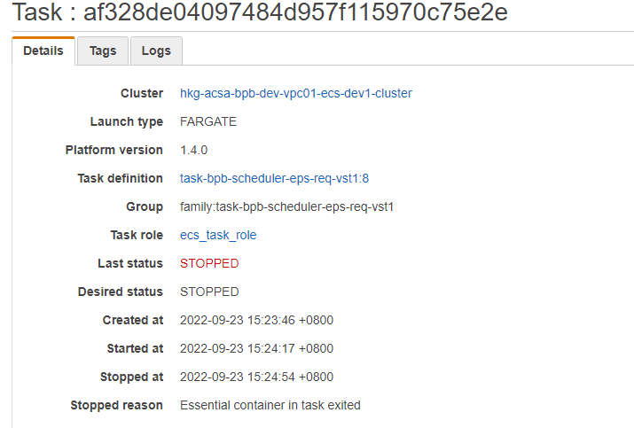

**Scenario 1:** Resend with additional list

**Result:** No file generated

