Summary:

UAT-2-BillPayment -Active/Disable Merchant category list & Active/Disable Merchant Name list not visible showing Error ' 500 Server Went Wrong

Merchant Category list is visible

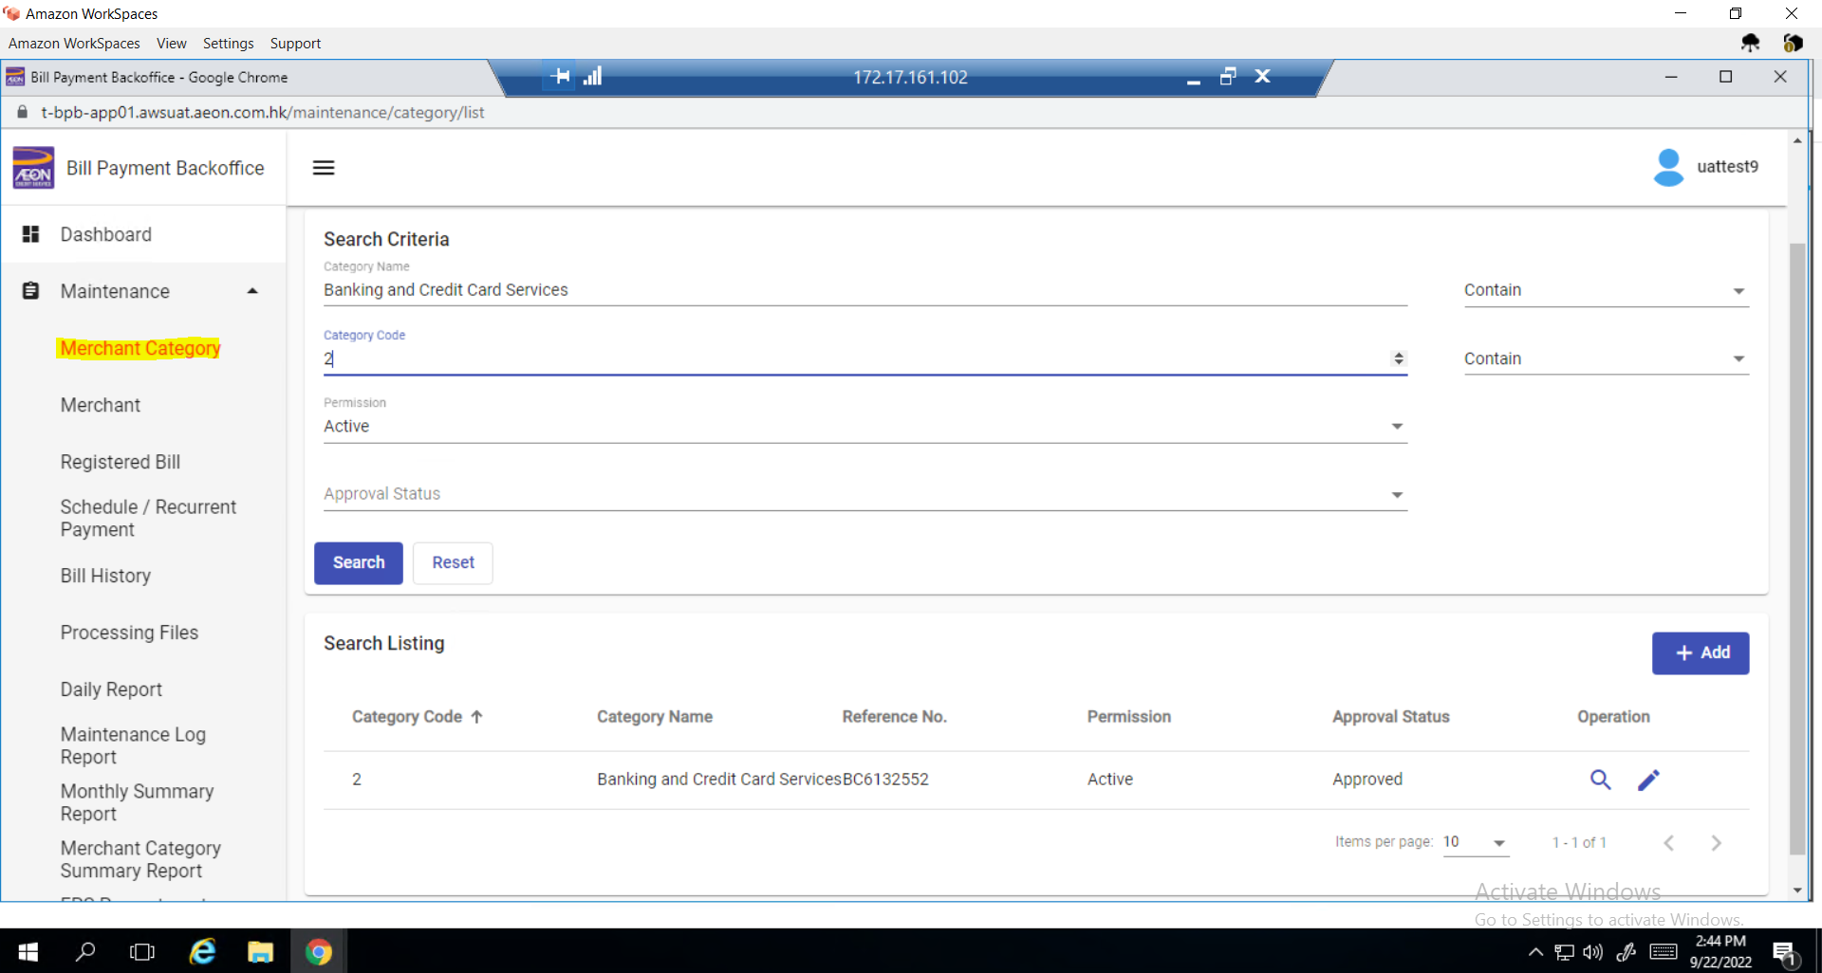

In Merchant Name list not shown displays error

