Virtual CC Copywriting

Image | ID | EN
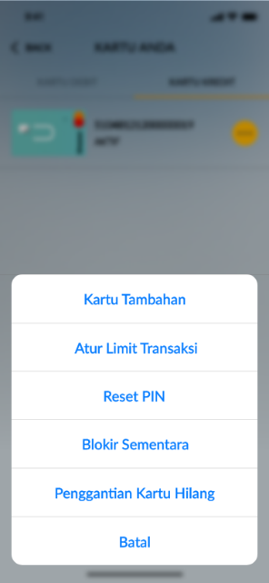 | - Kartu Tambahan  - Atur Limit Transaksi  - Reset PIN  - Blokir Sementara  - Penggantian Kartu Hilang  - Batal | - Supplementary Card  - Set Transaction Limit  - Reset PIN  - Temporary Blockir  - Lost Card Replacement  - Cancel
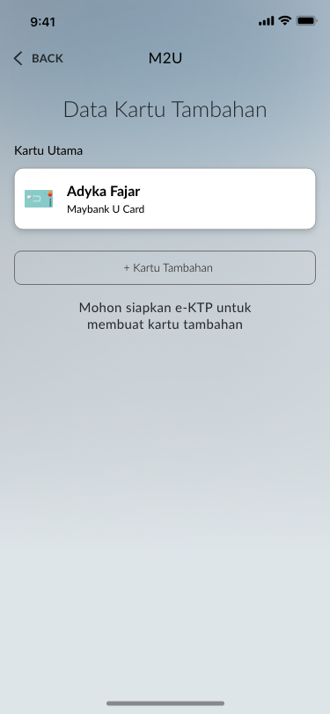 | - Data Kartu Tambahan  - Kartu Utama  - + Kartu Tambahan  - Mohon siapkan e-KTP untuk membuat kartu Tambahan | - Supplementary Card Data  - Main Card  - + Supplementary Card  - Please prepare your e-KTP to apply supplementary card
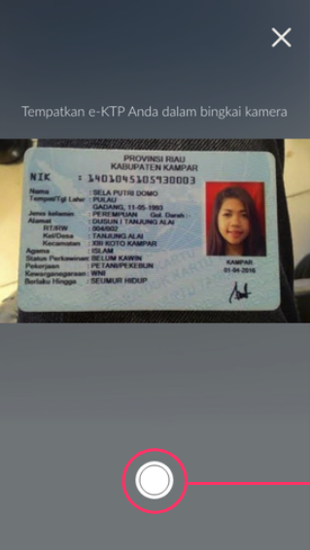 | Tempatkan e-KTP Anda dalam bingkai kamera | Place our ID in the camera frame
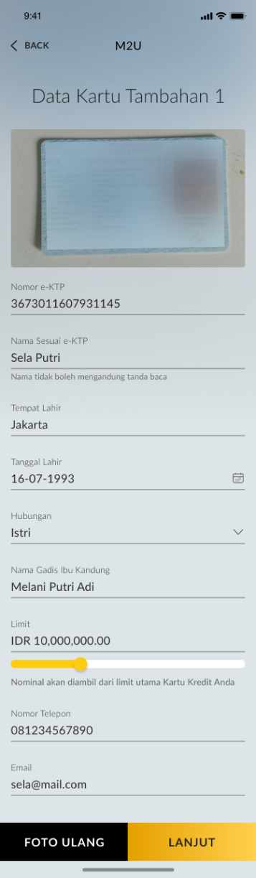 | - Data kartu Tambahan  - Nomor e-KTP  - Nama Sesuai e-KTP  - Nama tidak boleh mengandung tanda baca  - Tempat Lahir  - Tanggal Lahir  - Hubungan  - Pasangan  - Anak  - Nama Gadis Ibu Kandung  - Limit  - Nominal akan diambil dari limit utama Kartu Kredit Anda  - Nomor Telepon  - Email | - Supplementary Card Data  - E-KTP Number  - E-KTP Name  - Name must not contain punctuation marks  - Place of Birth  - Birthdate  - Relation  - Spouse  - Child  - Mother’s Maiden Name  - Limit  - Nominal will be taken from the main limit of your Credit Card  - Phone Number  - Email
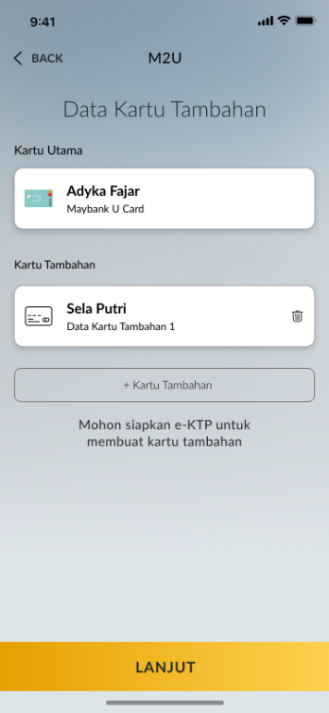 | - Data Kartu Tambahan  - Kartu Utama  - Kartu Tambahan  - + Kartu Tambahan  - Mohon siapkan e-KTP untuk membuat kartu Tambahan | - Supplementary Card  - Main Card  - Supplementary Card  - + Supplementary Card  - Please prepare your e-KTP to apply supplementary card
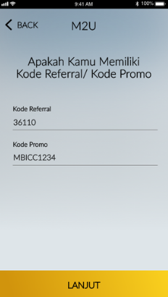 | - Apakah Anda Memiliki Kode Referral/Kode Promo  - Kode Referral  - Kode Promo | - Do you have a Referral Code/Promo Code  - Referral Code  - Promo Code
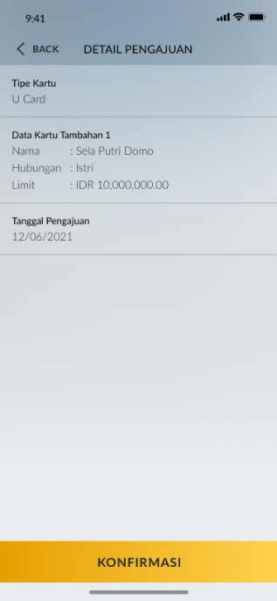 | - Detail Pengajuan  - Tipe Kartu  - Data Kartu Tamabahan 1  - Tanggal Pengajuan | - Apply Details  - Card Type  - Supplementary Card Data 1  - Apply Date
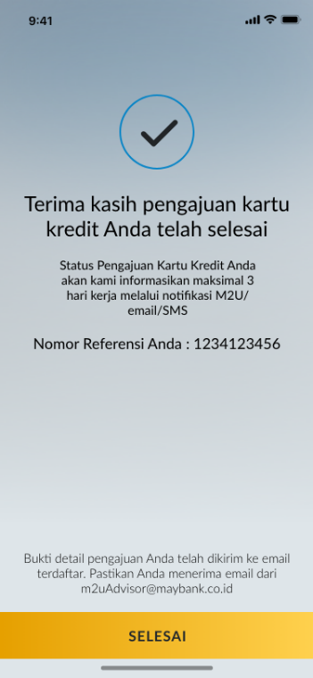 | Terima kasih, pengajuan kartu kredit Anda telah selesai  Status Pengajuan Kartu Kredit Anda akan kami informasikan maksimal 3 hari kerja melalui notifikasi M2U/email/SMS  Bukti detail pendaftaran Anda telah dikirim ke email terdaftar. Pastikan Anda menerima email dari m2uAdvisor@maybank.co.id | Thank you, your credit card application has been completed  We will inform you of the status of your credit card application in a maximum of 3 working days via M2U/email/SMS notification  Your registration details receipt has been sent to the registered email. Make sure you receive and email from m2uAdvisor@maybank.co.id

