**Issue 1:**

User id – Ultraman2

CIF – 8014445

Condition: Have Other AFT at Host (non IB AFT) only

Issue: Encounter error MiB00002 after submit for termination

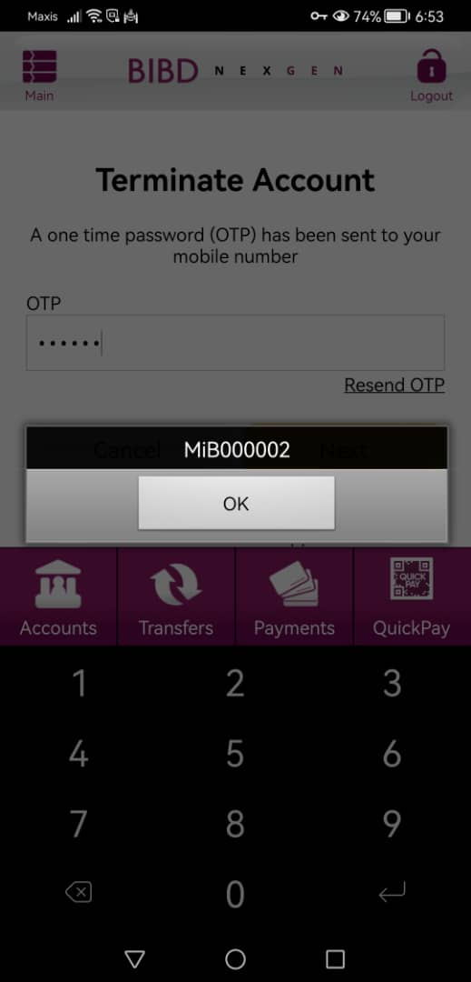

**Issue 2:**

User id – NODEBITCARD22

CIF – 340000037

Condition: Have IB AFT Transfer at 2 different CASA

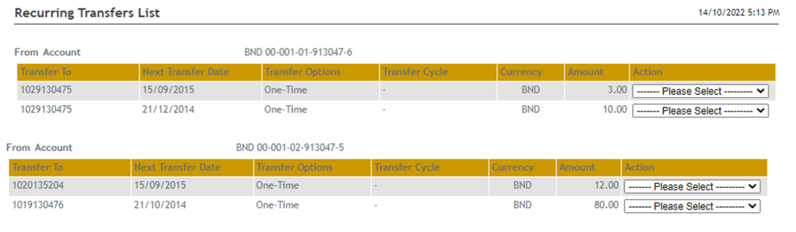

Steps:

1. Terminate NODEBITCARD22 (done on Friday 14/10/2022)
2. Register again from RIB
3. Verify AFT

Issue: One of the CASA accounts still have the AFT record

