MY TREATS Copywriting

Image | ID | EN
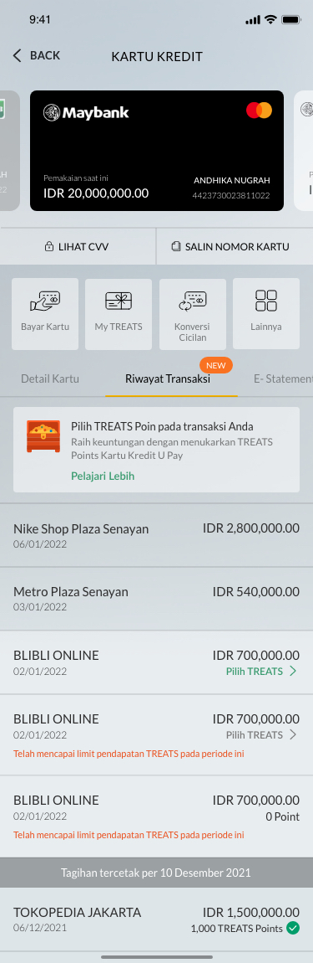 | - Tagihan tercetak per  - Pilih TREATS Poin pada transaksi Anda  Raih keuntungan menukarkan TREATS Point Kartu Kredit U Pay (only appears for U Pay Credit Card)  Pelajari Lebih  - Telah mencapai limit pendapatan TREATS pada periode ini  - Filter | - Bill Statement as of  - Select TREATS Points on your transaction  Get the benefits of exchanging TREATS Points for U Pay Credit Cards  Learn More  - Maximum limit earning TREATS on this billing cycle  - Filter
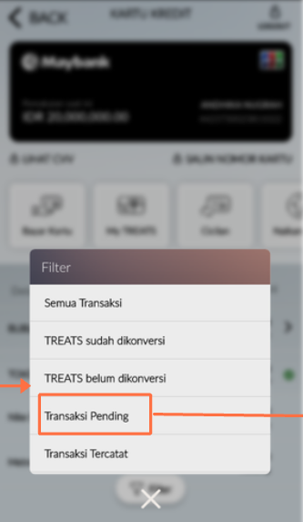 | - Semua Transaksi  - TREATS sudah dikonversi  - TREATS belum dikonversi  - Transaksi Pending  - Transaksi Tercatat | - All Transaction  - Converted TREATS  - Not been converted TREATS  - Pending Transaction  - Posted Transaction
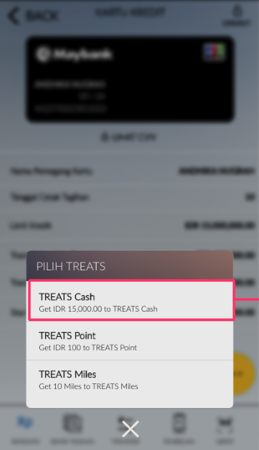 | - Pilih TREATS  - TREATS Cash  - TREATS Point  - TREATS Miles | - Choose TREATS  - TREATS Cash  - TREATS Point  - TREATS Miles
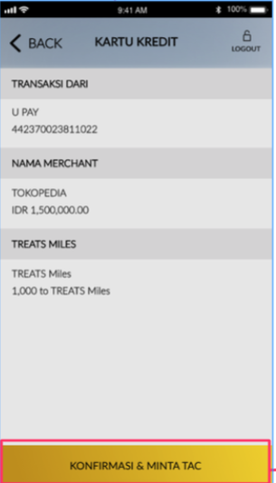 | - Transaksi Dari  - Nama Merchant  - X,000 ke TREATS Cash/Poin/Miles  - KONFIRMASI & MINTA TAC | - Transaction From  - Merchant Name  - X,000 to TREATS Cash/Point/Miles  - CONFIRM & REQUEST TAC
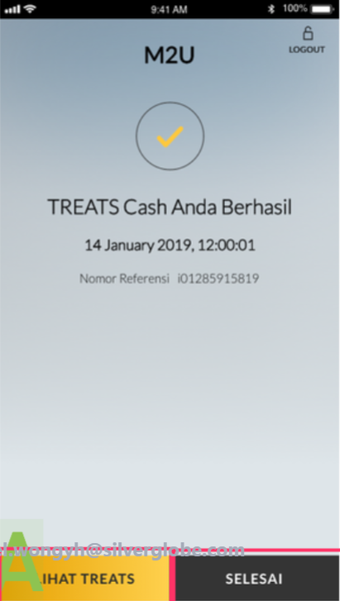 | - TREATS [Cash/Poin/Miles] Anda Berhasil  - Nomor Referensi  - LIHAT TREATS  - SELESAI | - TREATS [Cash/Point/Miles] is Successful  - Reference Number  - MY TREATS  - DONE
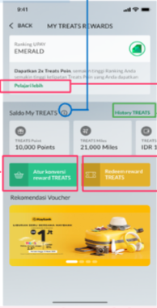 | - My TREATS Rewards  - Ranking UPAY  - Dapatkan 2x Treats Poin, semakin tinggi Ranking Anda semakin tinggi kelipatan Treats Poin yang Anda dapatkan  Pelajari Lebih  - Saldo My TREATS  - History TREATS  - Atur Konversi TREATS  - Redeem reward TREATS | - My TREATS Rewards  - UPAY Ranking  - Get 2x Treats Point, the higher your Ranking, the higher you will get Treats Point  Learn More  - My TREATS Balance  - TREATS History  - TREATS Conversion Setting  - TREATS Reward Redemption
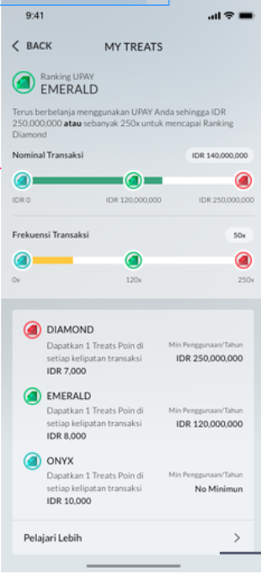 | - Ranking UPAY  - Terus berbelanja menggunakan UPAY Anda sehingga IDR 250,000,000 atau sebanyak 250x untuk mencapai Ranking Diamond  - Nominal Transaksi  - Frekuensi Transaksi  - Dapatkan 1 TREATS Poin di setiap kelipatan transaksi [IDR 7,000/8,000/10,000]  - Min Penggunaan/Tahun  - Pelajari Lebih | - UPAY Ranking  - Spend more with UPAY up to IDR 250,000,000 or 250 times to reach Diamond Ranking  - Transaction Amount  - Transaction Frequency  - Get 1 TREATS Point for every [IDR 7,000/IDR 8,000/IDR 10,000] in each transaction  - Min Spend/Year  - Learn More
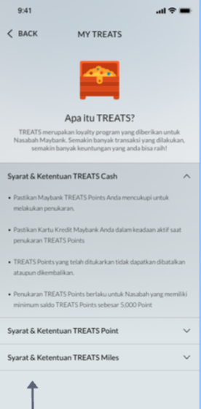 | [Diatur melalui Back Office] | [Diatur melalui Back Office]
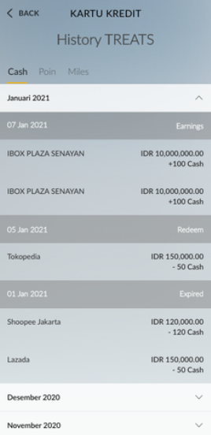 | - History TREATS  - Cash | Point | Miles  - Earnings | Redeem | Expired | - TREATS History  - Cash | Points | Miles  - Earnings | Redeem | Expired
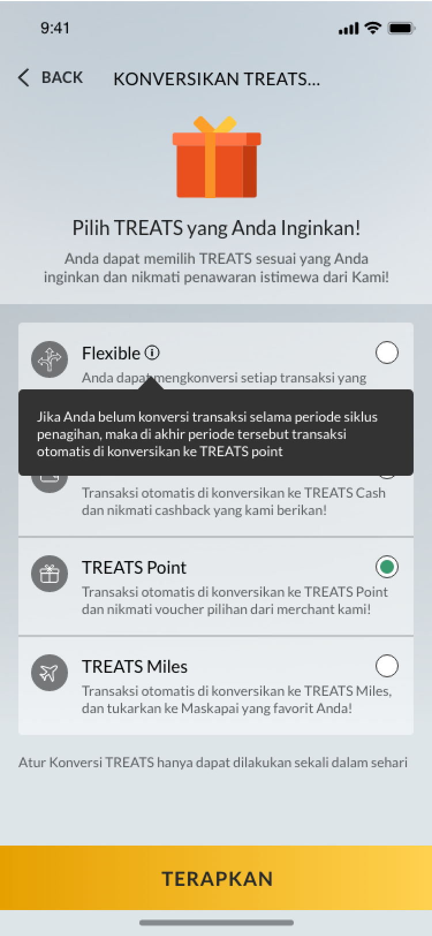 | - Konversikan TREATS Anda  - Pilih TREATS yang Anda Inginkan!  - Anda dapat memilih TREATS sesuai yang Anda inginkan dan nikmati penawaran istimewa dari kami!  - Flexible  Anda dapat mengkonversi transaksi yang Anda lakukan menjadi TREATS Cash, TREATS Poin, TREATS Miles sesuai yang Anda inginkan!  - [Tooltip Flexible]  Jika Anda belum konversi transaksi selama periode siklus penagihan, maka di akhir periode tersebut transaksi otomatis dikonversikan ke TREAT Point  - TREATS Cash  Transaksi otomatis dikonversikan ke TREATS Cash dan nikmati cashback yang kami berikan!  - TREATS Point  Transaksi otomatis dikonversikan ke TREATS Point dan nikmati voucher pilihan dari merchant kami!  - TREATS Miles  Transaksi otomatis dikonversikan ke TREATS Miles dan tukarkan ke Poin Maskapai yang Anda inginkan!  - Atur konversi TREATS hanya dapat dilakukan sekali dalam sehari  - TERAPKAN | - Convert Your TREATS  - Select the TREATS You Want!  - Choose TREATS that you want and enjoy special offers from us!  - Flexible  You can convert the transactions you make into TREATS Cash, TREATS Point, TREATS Miles as you wish!  - [Tooltip Flexible]  If you haven’t converted the transactions within billing cycle, at the end of the cycle each transaction will be converted into TREAT Point  - TREATS Cash  Transactions are automatically converted to TREATS Cash and enjoy the cashback we provide!  - TREATS Points  Transactions are automatically converted to TREATS Points and enjoy selected vouchers from our merchants!  - TREATS Miles  Transactions are automatically converted to TREATS Miles and exchanged to your desired Airline Points!  - Set the TREATS conversion can only be done once a day  - APPLY
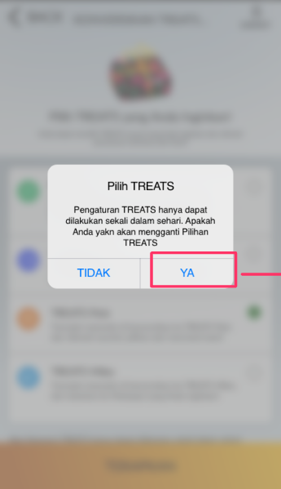 | - Pilih TREATS  - Pengaturan TREATS hanya dapat dilakukan sekali dalam sehari. Apakah Anda yakin akan mengganti pilihan TREATS?  - TIDAK/ YA | - Select TREATS  - TREATS settings can only be done once a day. Are you sure you want to change the TREATS option?  - NO/ YES
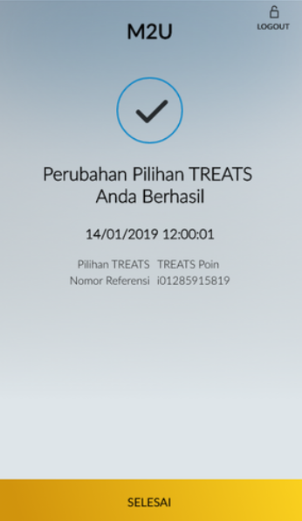 | - Perubahan Pilihan TREATS Anda Berhasil  - Pilihan TREATS  - Nomor Referensi | - Your TREATS Option Change Successful  - TREATS Option  - Reference Number
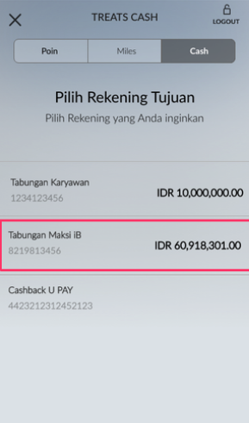 | - TREATS CASH  - Point  - Miles  - Cash  - Pilih Rekening Tujuan  - Pilih Rekening yang Anda inginkan | - Treats Cash  - Points  - Miles  - Cash  - Select Destination Account  - Select Account You want
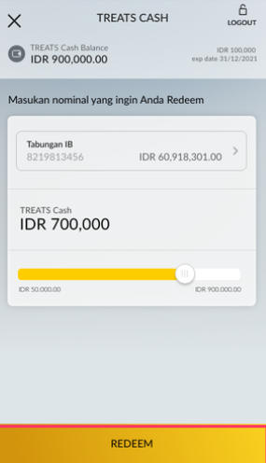 | - Saldo TREATS Cash  - exp date  - Masukkan nominal yang ingin Anda Redeem  - REDEEM | - TREATS Cash Balance  - exp date  - Enter the amount you want to Redeem  - REDEEM
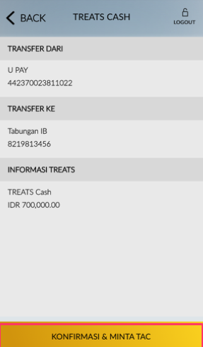 | - Transfer Dari  - Transfer Ke  - Informasi TREATS | - Transfer From  - Transfer To  - TREATS Information
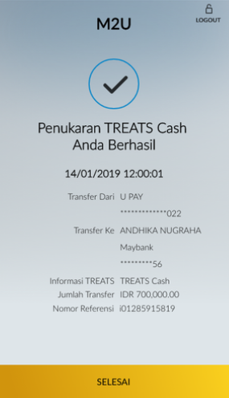 | - Penukaran TREATS Cash Anda Berhasil  - Transfer Dari  - Transfer Ke  - Informasi TREATS  - Jumlah Transfer  - Nomor Referensi | - Your TREATS Cash Exchange is Successful  - Transfer From  - Transfer To  - TREATS Information  - Transfer Amount  - Reference Number
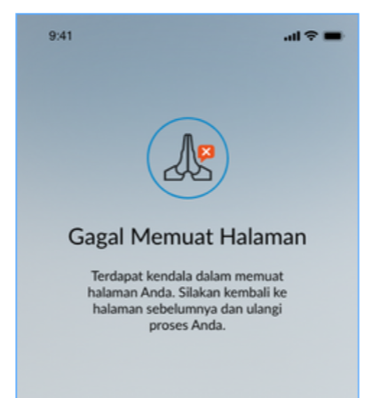 | Gagal Memuat Halaman  Terdapat kendala dalam memuat halaman Anda. Silakan kembali ke halaman sebelumnya dan ulangi proses Anda. | Failed to Load  Unable to load your page. Please access the previous screen and retry.
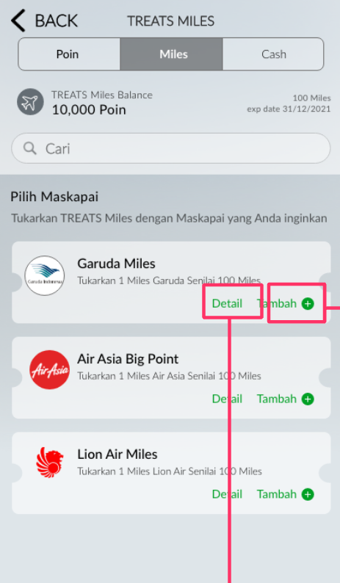 | - TREATS MILES  - Saldo TREATS Miles  - Pilih Maskapai  - Tukarkan TREATS Miles dengan Maskapai yang Anda inginkan  - Tukarkan 100 TREATS Miles dengan xxx Miles [Nama Airline]  - Detil  - Tambah | - TREATS MILES  - TREATS Miles Balance  - Choose an Airline  - Redeem TREATS Miles with the Airline you want  - Exchange 100 TREATS Miles for xxx Miles [Nama Airline]  - Details  - Add
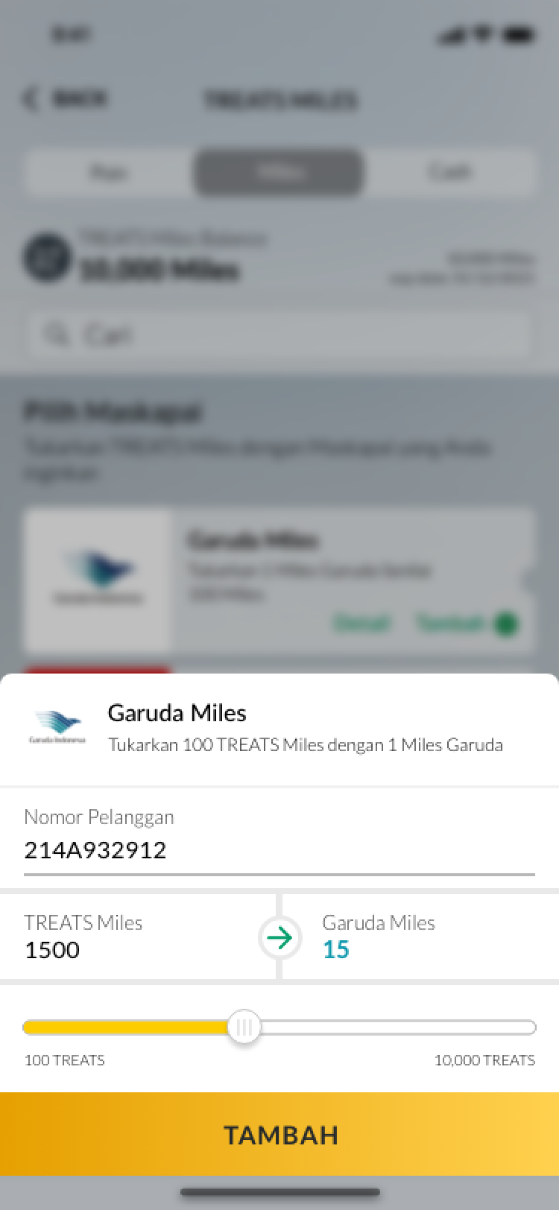 | - Tukarkan 100 TREATS Miles dengan xxx Miles [Nama Airline]  - Nomor Pelanggan  - TREATS Miles | [Airline] Miles  - xxx TREATS  - TAMBAH | - Exchange 100 TREATS Miles for xxx Miles [Nama Airline]  - Customer Number  - TREATS Miles | [Airline] Miles  - xxx TREATS  - ADD
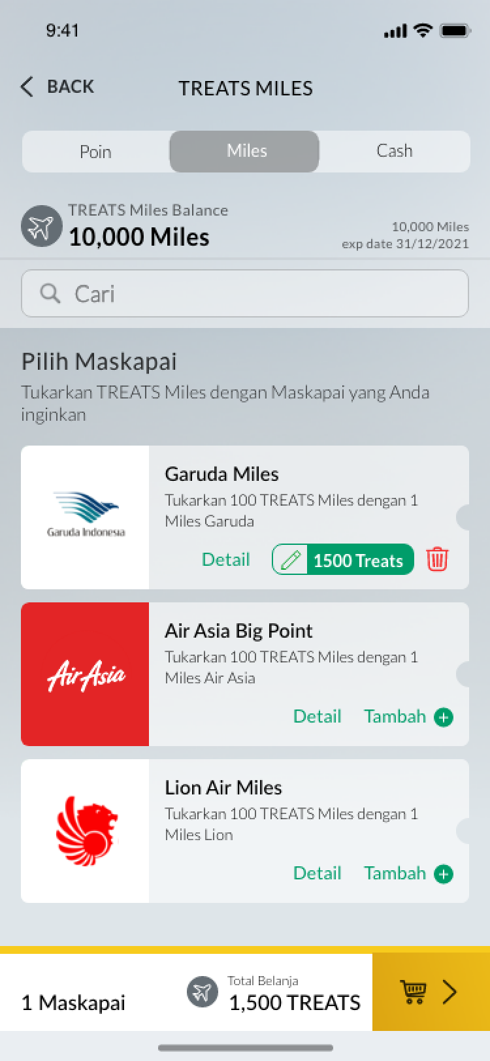 | - X maskapai  - Total Belanja | - X Airlines  - Shopping Total
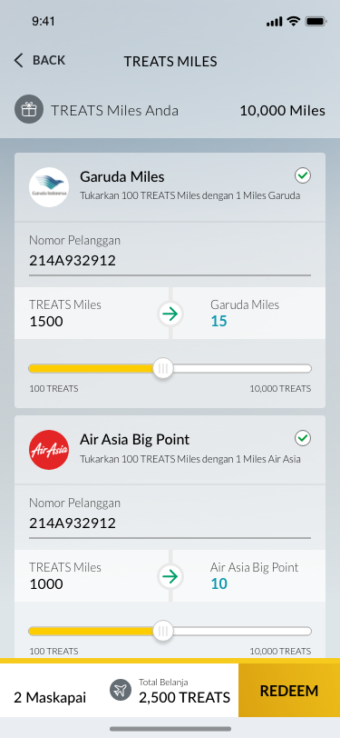 | - TREATS Miles Anda  - REDEEM | - Your TREATS Miles  - REDEEM
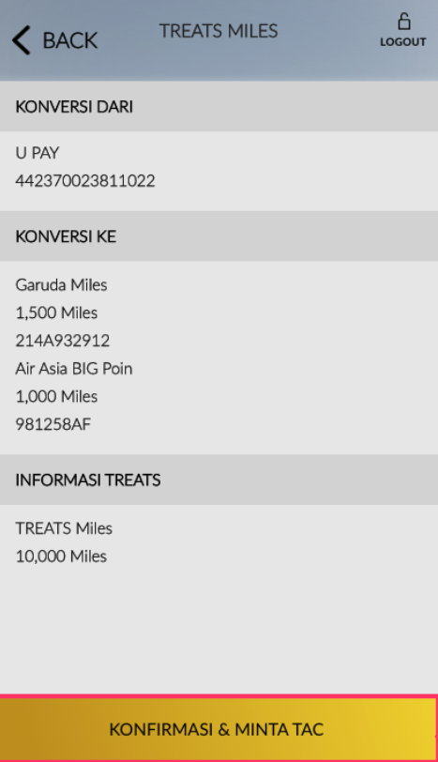 | - Konversi Dari  - Konversi Ke  - Informasi TREATS | - Redeem From  - Redeem To  - TREATS Information
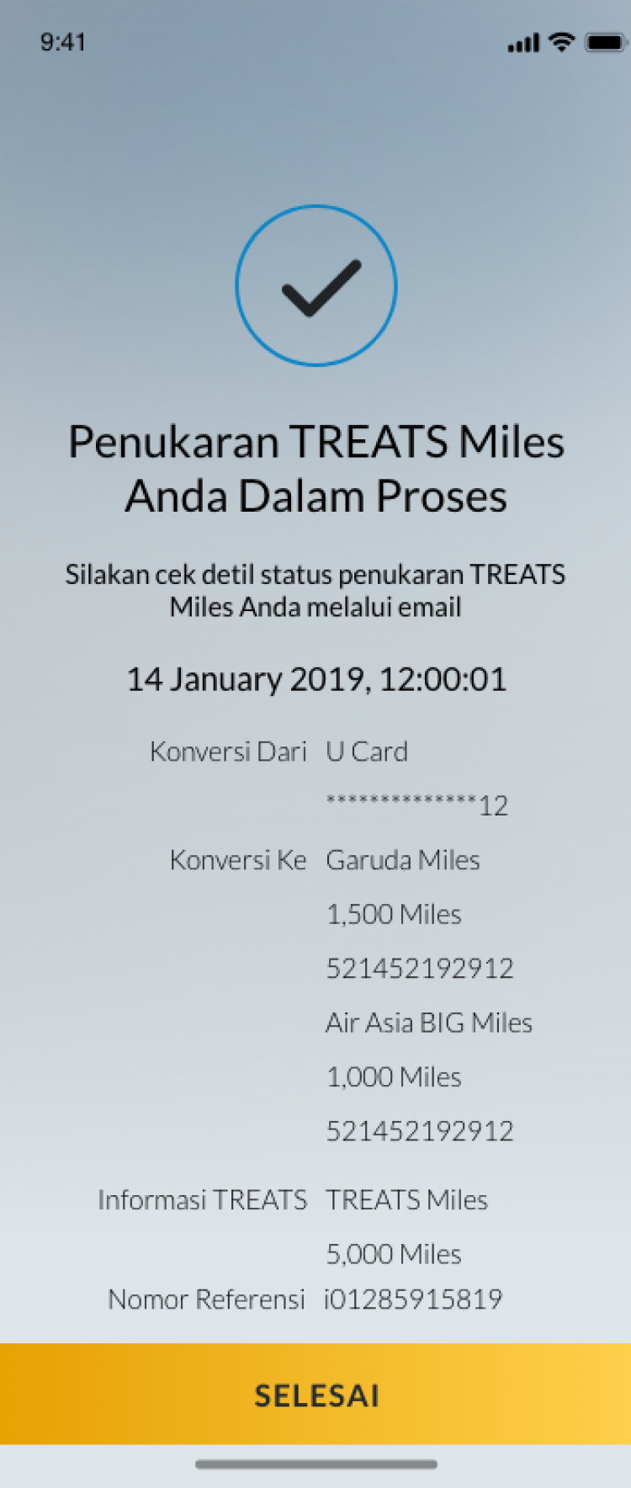 | - Penukaran TREATS Miles Anda dalam Proses  - Silakan cek detil status penukaran TREATS Miles Anda melalui email  - Konversi Dari  - Konversi Ke  - Informasi TREATS  - Nomor Referensi  - SELESAI | - Your TREATS Miles Redemption is in Progress  - Please check your TREATS Miles redemption status via email  - Redeem From  - Redeem To  - TREATS Information  - Reference Number  - DONE
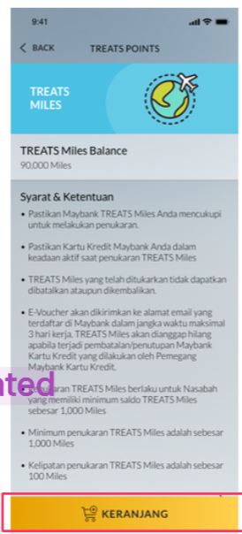 | - TREATS MILES  - Saldo TREATS Miles  - Syarat & Ketentuan  [T&C content depends on back office loyalty]  - KERANJANG | - TREATS MILES  - TREATS Miles Balance  - Terms & Conditions  [T&C content depends on back office loyalty]  - CART
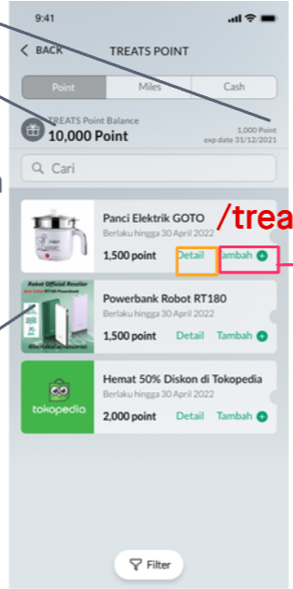 | Vouchers content depends on merchant  - TREATS POINT  - Saldo TREATS Point  - Xxx Point  - Exp date  - Cari  - Detil  - Tambah | Vouchers content depends on merchant  - TREATS POINT  - TREATS Point Balance  - Xxx Point  - Exp date  - Search  - Detail  - Add
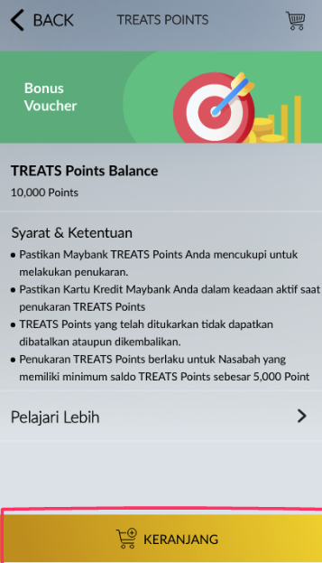 | Vouchers content depends on merchant | Vouchers content depends on merchant
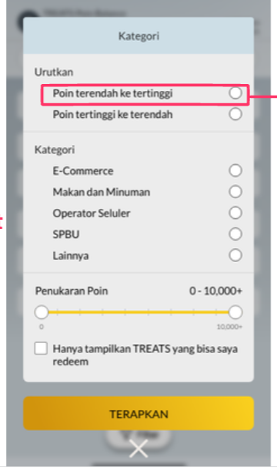  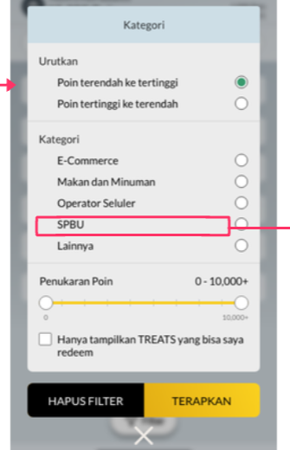 | - Kategori  - Urutkan  - Poin terendah ke tertinggi  - Poin tertinggi ke terendah  - Kategori  - E-Commerce  - Makan dan Minuman  - Operator Seluler  - SPBU  - Lainnya  - Penukaran Poin  - Hanya tampilkan TREATS yang bisa saya redeem  - Hapus Filter  - Terapkan | - Categories  - Sort  - Lowest to highest points  - Highest points to lowest  - Categories  - E-Commerce  - Food and Drink  - Mobile Operators  - gas station  - Other  - Points Redemption  - Only show TREATS that I can redeem  - Filter Reset  - Apply
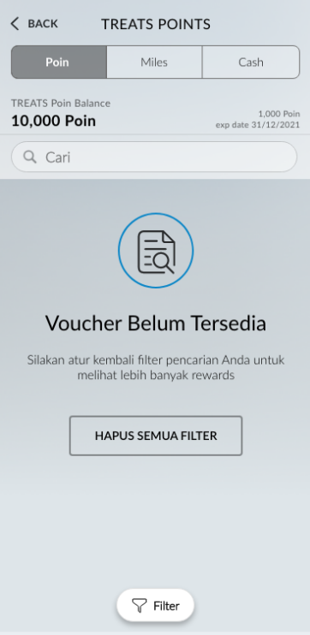 | - Voucher Belum Tersedia  - SIlakan atur kembali filter pencarian Anda untuk melihat lebih banyak rewards  - HAPUS SEMUA FILTER | - Vouchers Not Available  - Please reset your search filter to see more rewards  - RESET FILTERS
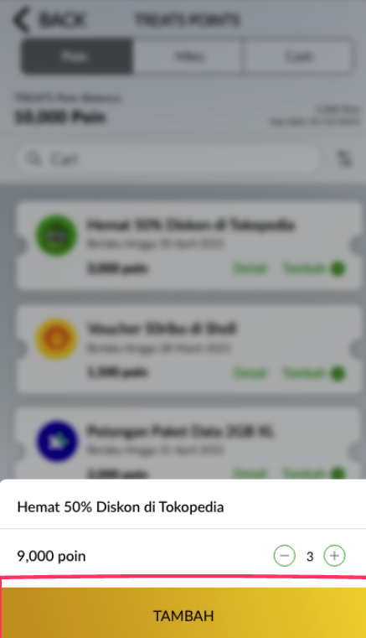 | - Tambah | - Add
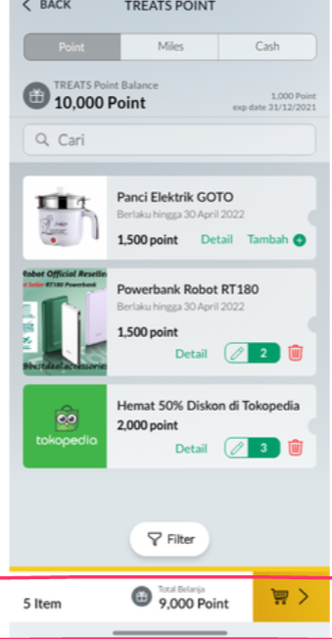 | - N Item  - Total Belanja | - N Item(s)  - Shopping Total
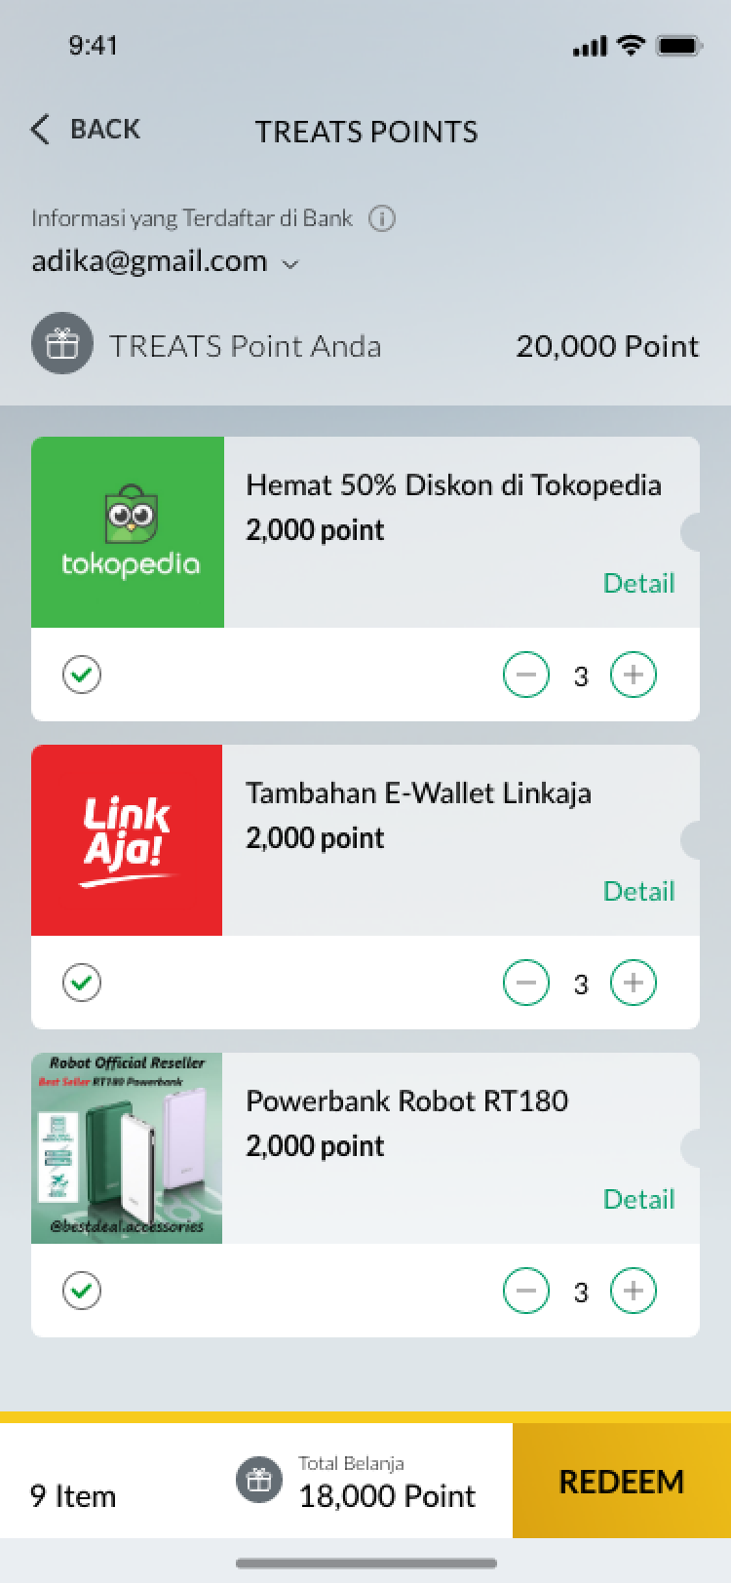  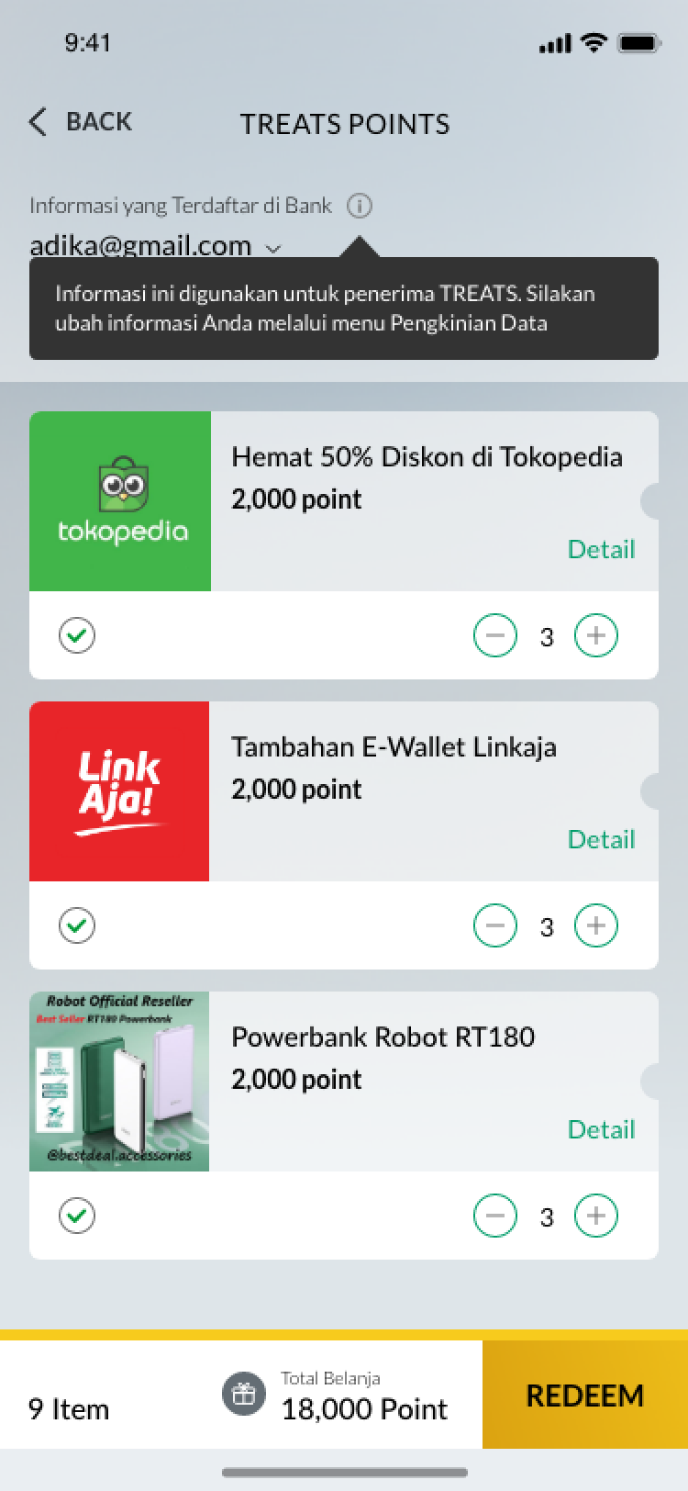 | - Informasi Anda yang Terdaftar di Bank  - TREATS Point Anda  - [Tooltip]  Informasi Anda digunakan untuk penerima TREATS. Silakan ubah informasi Anda melalui menu Pengkinian Data | - Your Registered Information at Bank  - Your TREATS Points  - [Tooltip]  Your information will be used as the source of TREATS recipient. Please change your information through Customer Profile Update menu.
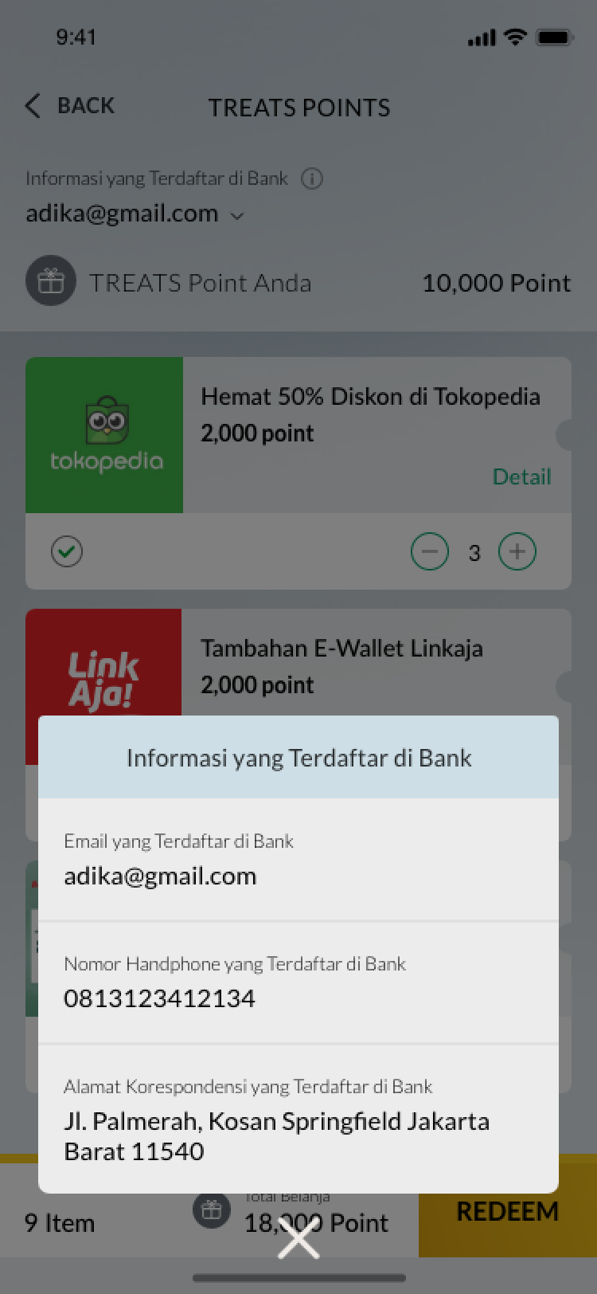 | - Email yang Terdaftar di Bank  - Nomor Handphone yang Terdaftar di Bank  - Alamat Korespondensi yang Terdaftar di Bank | - Registered Email at the Bank  - Registered Phone Number at the Bank  - Registered Address at the Bank
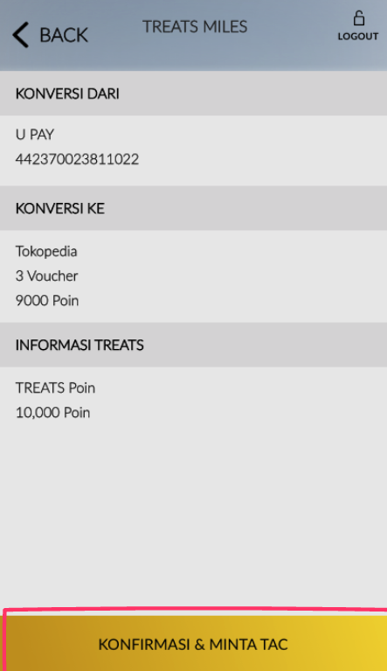 | - Konversi Dari  - Konversi Ke  - Informasi TREATS | - Redeem From  - Redeem To  - TREATS Information
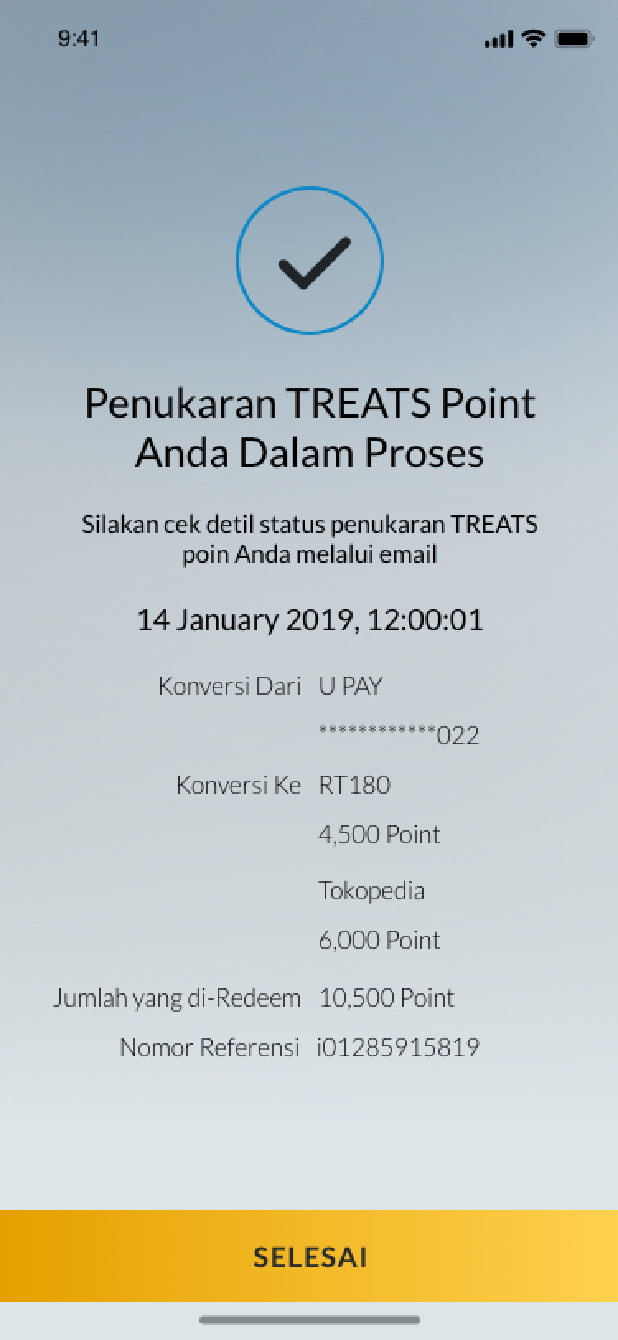 | - Penukaran TREATS Poin Anda Dalam Proses  - Silakan cek detil status penukaran TREATS Point Anda melalui email  - Konversi Dari  - Konversi Ke  - Jumlah yang di-Redeem  - Nomor Referensi  - SELESAI | - Your TREATS Points Redemption is in Progress  - Please check your TREATS Point redemption status via email  - Redeem From  - Redeem To  - Redemption Amount  - Reference Number  - DONE
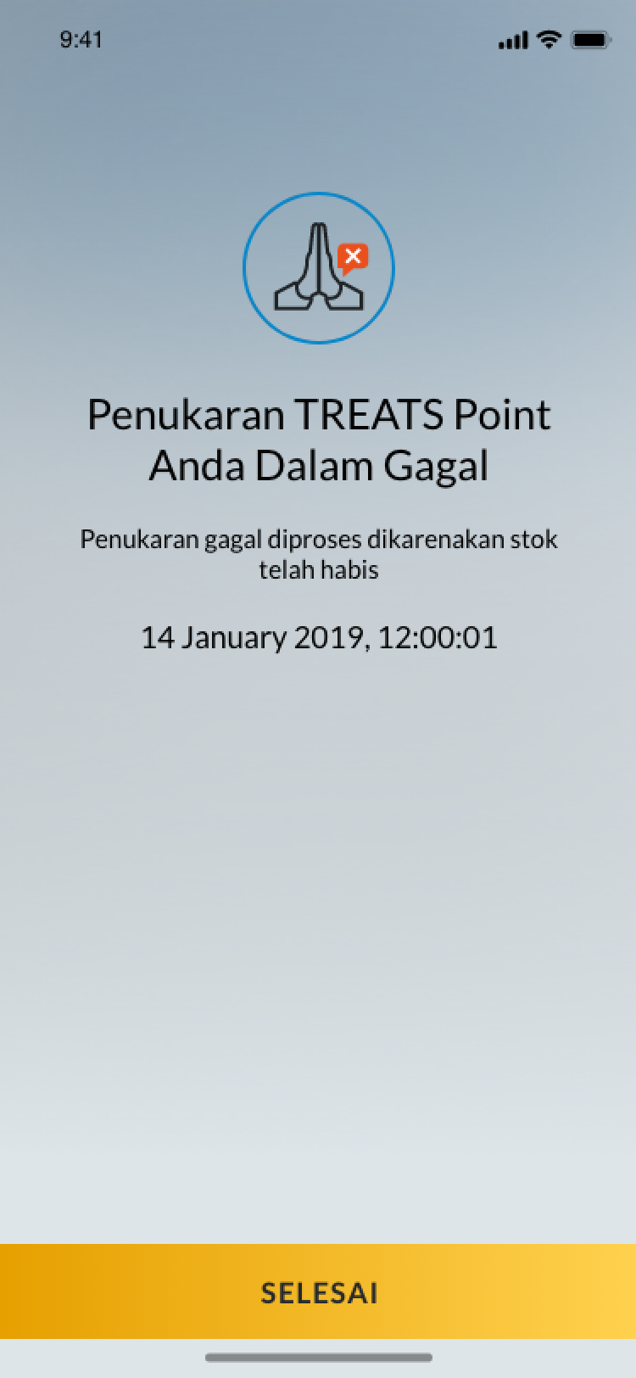 | - Penukaran TREATS Point Anda Gagal  - Penukaran gagal diproses dikarenakan stok telah habis  - SELESAI | - Your TREATS Point Redemption is Unsuccessful  - Redemption is unsuccessful due to stock unavailability  - DONE

