User profile detail

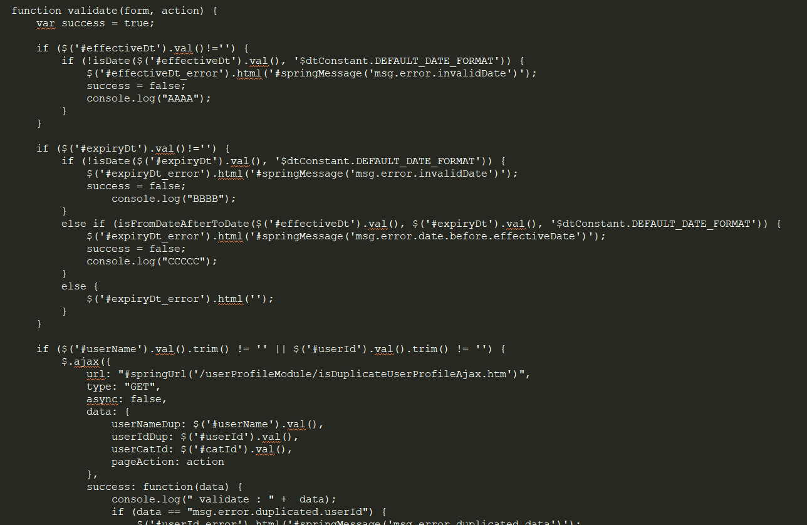

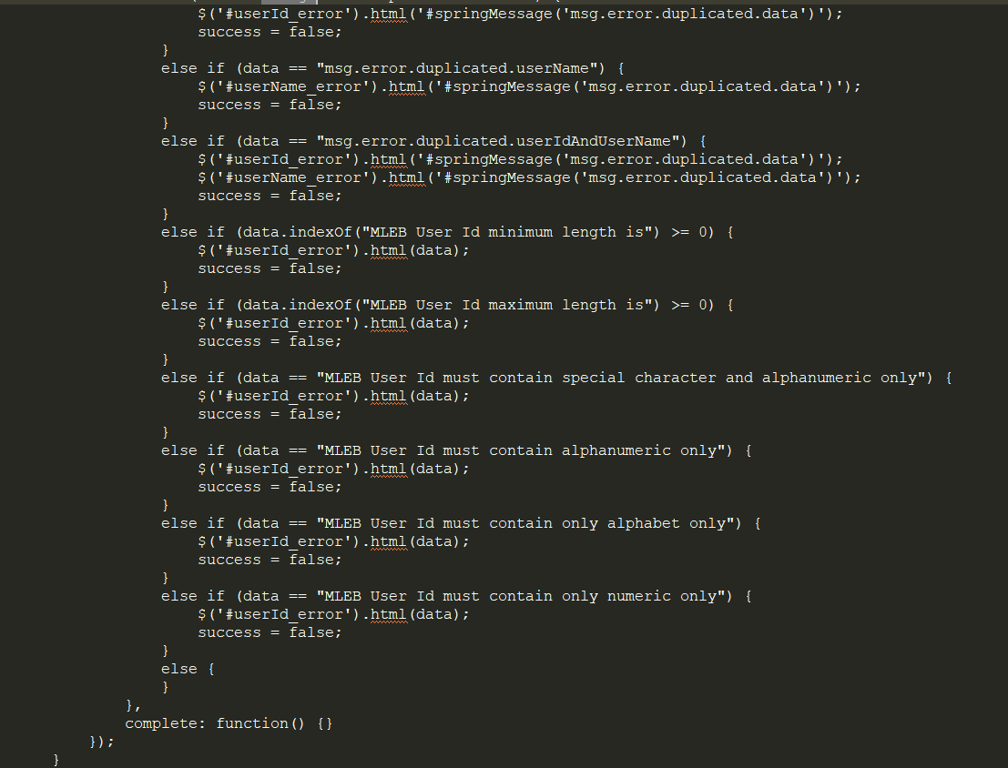

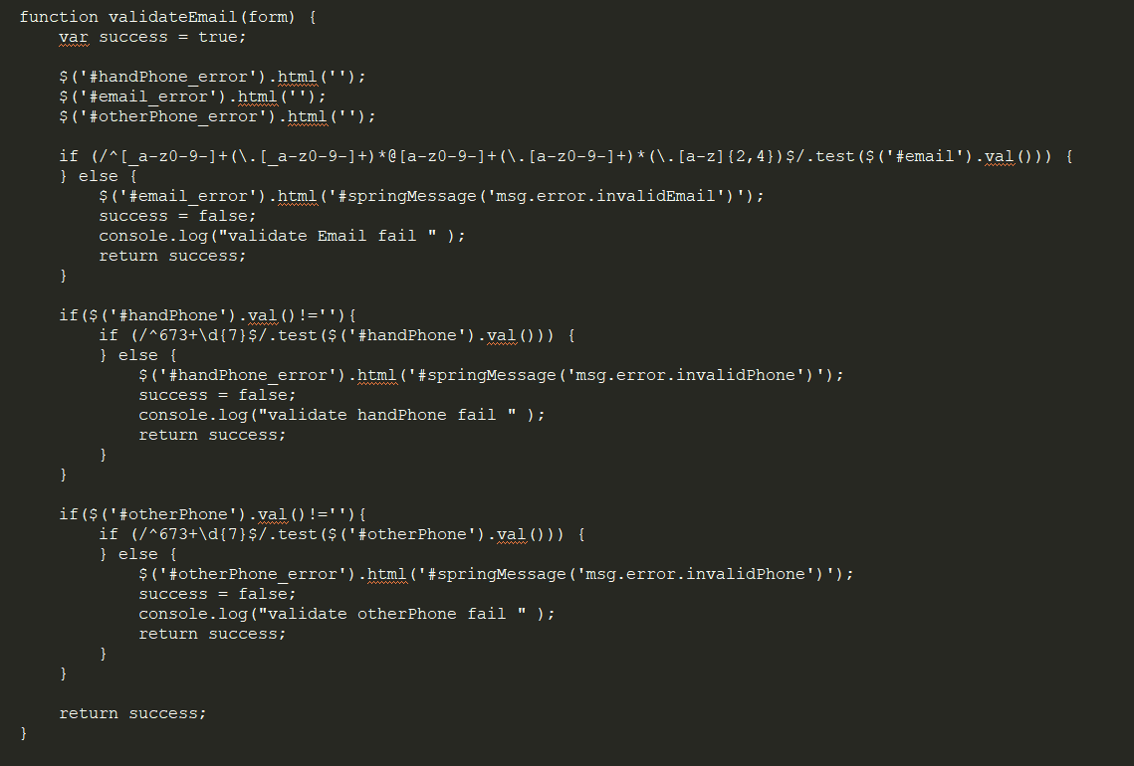

Validation impact:

1. effectiveDt
2. username
3. validate email
4. expiryDt
5. handphone
6. otherPhone

my profile

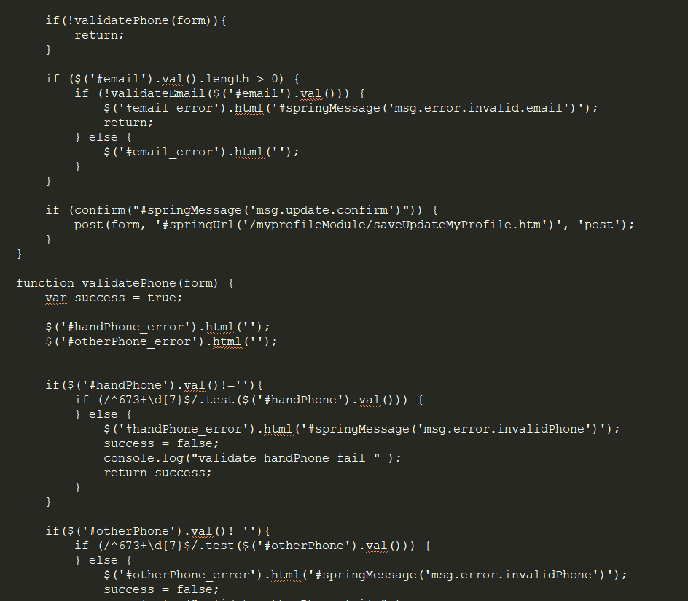

Validation impact:

1. email
2. phone
3. other phone

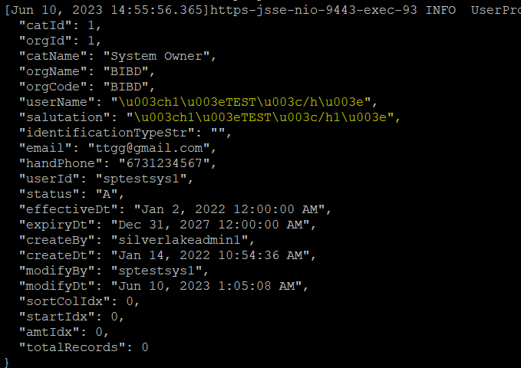

Attachment 1