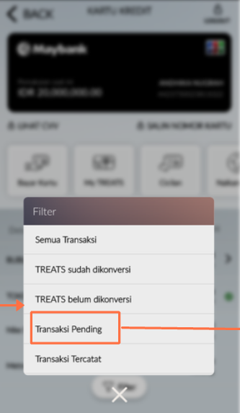 | - Semua Transaksi  - TREATS sudah dikonversi  - TREATS belum dikonversi  - Transaksi Pending  - Transaksi Tercatat | - All Transaction  - Converted TREATS  - Not been converted TREATS  - Pending Transaction  - Posted Transaction

