BEFORE:

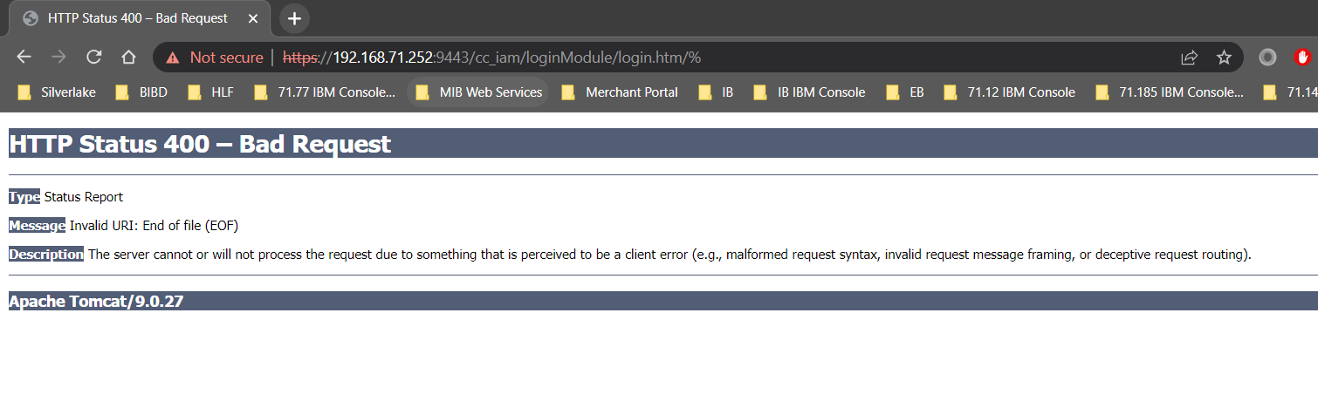AFTER:

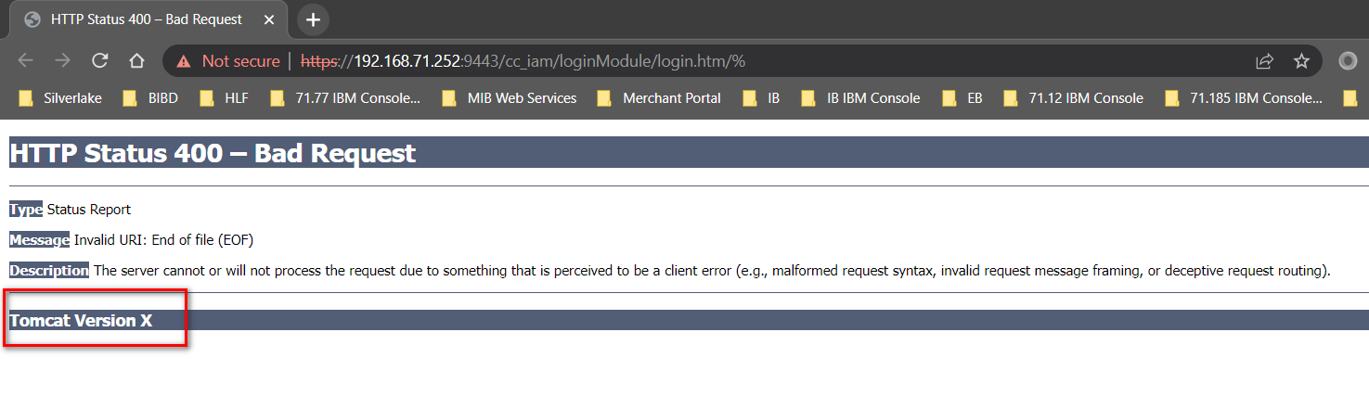

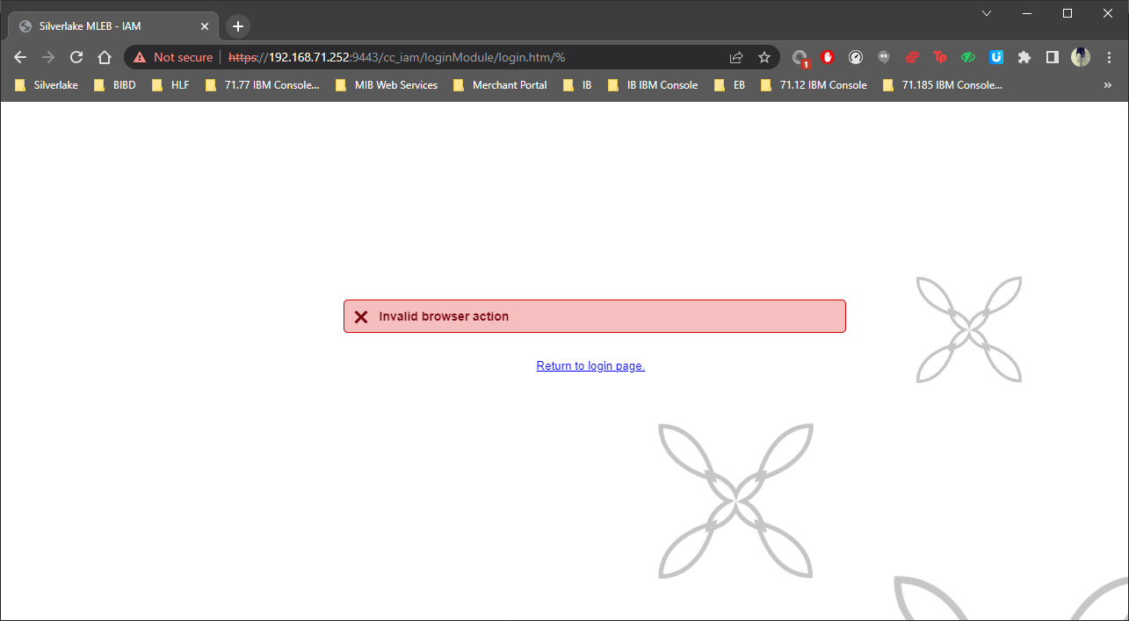

**CHANGES (SYSTEM OWNER AND MERCHANT)**

1. Create new ***ServerInfo.properties*** filein new created folder(s) /lib***/org/apache/catalina/util*** to remove Tomcat version
2. Modify server.xml to display custom static error page for all different error context
   1. Add in Host section

***<Valve className="org.apache.catalina.valves.ErrorReportValve" errorCode.0="webapps/ROOT/404.htm" showReport="false" showServerInfo="false" />***

1. Modify web.xml:
   1. Enable httpHeaderSecurity
   2. Add hstsEnabled

***<init-param>***

***<param-name>hstsEnabled</param-name>***

***<param-value>true</param-value>***

***</init-param>***

* 1. Enable filter-mapping httpHeaderSecurity
  2. Add in session-config section

***<cookie-config>***

***<http-only>true</http-only>***

***<secure>true</secure>***

***</cookie-config>***

Reference:

1. <https://docs.bmc.com/docs/security/basic-tomcat-security-configuration-recommendations-924057229.html>
2. <https://eliarms.medium.com/how-to-implement-httponly-and-secure-cookie-in-web-servers-ebad20427b94>
3. <https://stackoverflow.com/questions/52814582/tomcat-is-not-redirecting-to-400-bad-request-custom-error-page>