Virtual CC Copywriting – Digital Signature

Image | ID | EN
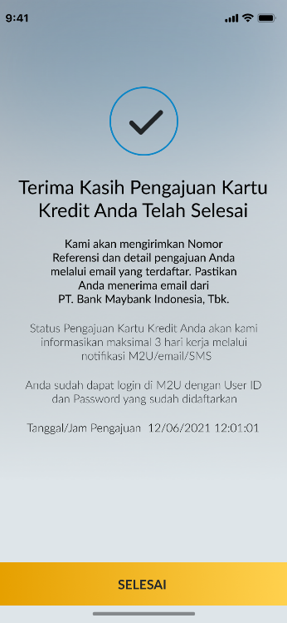  Saving – CC (Pre Login) | - Terima Kasih Pengajuan Kartu Kredit Anda Telah Selesai  - Kami akan mengirimkan Nomor Referensi dan detail pengajuan Anda melalui email yang terdaftar. Pastikan Anda menerima email dari PT. Bank Maybank Indonesia, Tbk.  - Status Pengajuan Kartu Kredit Anda akan kami informasikan maksimal 3 hari kerja melalui notifikasi M2U/email/SMS  - Anda sudah dapat login di M2U dengan User ID dan Password yang sudah didaftarkan  - Tanggal/Jam Pengajuan  - SELESAI | - Thank You Your Credit Card Application Has Been Completed  - We will send your Reference Number and application details to the registered email. Make sure you receive the email from PT. Bank Maybank Indonesia, Tbk.  - We will inform you the status of your credit card application in a maximum of 3 working days via M2U notification/email/SMS  - You can login to M2U using registered User ID and Password  - Date/Time of Submission  - DONE
CC – Saving (Pre Login)  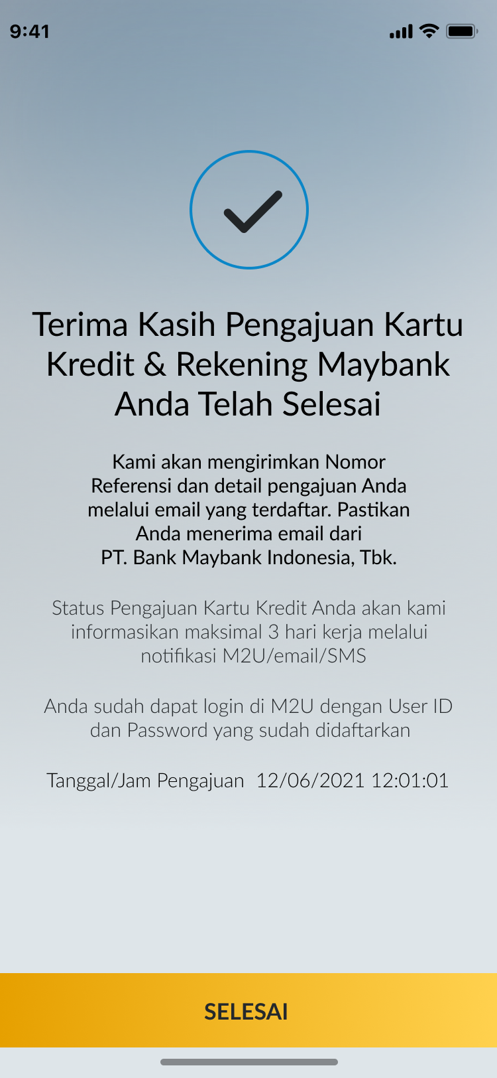 | - Terima Kasih Pengajuan Kartu Kredit & Rekening Maybank Anda Telah Selesai  - Kami akan mengirimkan Nomor Referensi dan detail pengajuan Anda melalui email yang terdaftar. Pastikan Anda menerima email dari PT. Bank Maybank Indonesia, Tbk.  - Status Pengajuan Kartu Kredit Anda akan kami informasikan maksimal 3 hari kerja melalui notifikasi M2U/email/SMS  - Anda sudah dapat login di M2U dengan User ID dan Password yang sudah didaftarkan  - Tanggal/Jam Pengajuan  - SELESAI | - Thank You Your Credit Card Application & Maybank Account Has Been Completed  - We will send your Reference Number and application details to the registered email. Make sure you receive the email from PT. Bank Maybank Indonesia, Tbk.  - We will inform you the status of your credit card application in a maximum of 3 working days via M2U notification/email/SMS  - You can login to M2U using registered User ID and Password  - Date/Time of Submission  - DONE
Saving+CC and CC+Saving (postlogin)  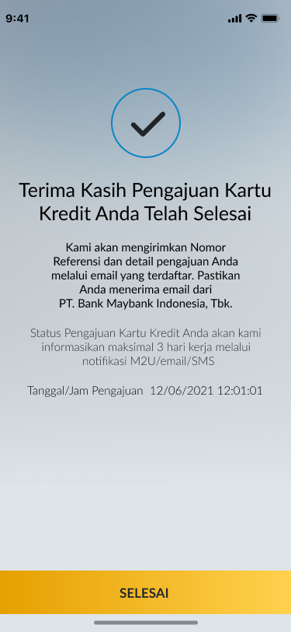 | - Terima Kasih Pengajuan Kartu Kredit Anda Telah Selesai  - Kami akan mengirimkan Nomor Referensi dan detail pengajuan Anda melalui email yang terdaftar. Pastikan Anda menerima email dari PT. Bank Maybank Indonesia, Tbk.  - Status Pengajuan Kartu Kredit Anda akan kami informasikan maksimal 3 hari kerja melalui notifikasi M2U/email/SMS  - Tanggal/Jam Pengajuan  - SELESAI | - Thank You Your Credit Card Application Has Been Completed  - We will send your Reference Number and application details to the registered email. Make sure you receive the email from PT. Bank Maybank Indonesia, Tbk.  - We will inform you the status of your credit card application in a maximum of 3 working days via M2U notification/email/SMS  - Date/Time of Submission  - DONE

