MY TREATS Copywriting

Image | ID | EN
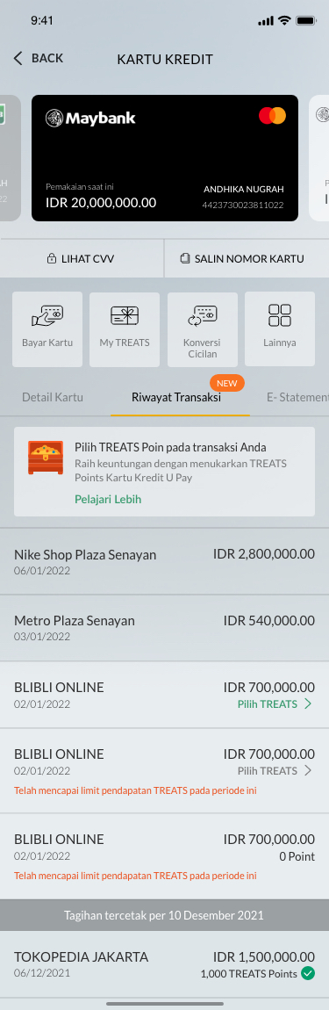 | - Tagihan tercetak per  - Pilih TREATS Points pada transaksi Anda  Raih keuntungan menukarkan TREATS Points Maybank Kartu Kredit  Pelajari Lebih  - Telah mencapai maksimum limit perolehan TREATS pada periode ini  - Filter | - Bill Statement as of  - Select TREATS Points on your transaction  Get the benefits of exchanging TREATS Points for Maybank Credit Cards  Learn More  - Maximum limit earning TREATS on this billing cycle  - Filter
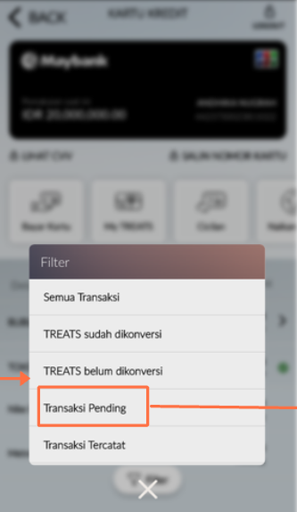 | - Semua Transaksi  - TREATS sudah dikonversi  - TREATS belum dikonversi  - Transaksi Pending  - Transaksi Tercatat | - All Transaction  - Converted TREATS  - Not been converted TREATS  - Pending Transaction  - Posted Transaction
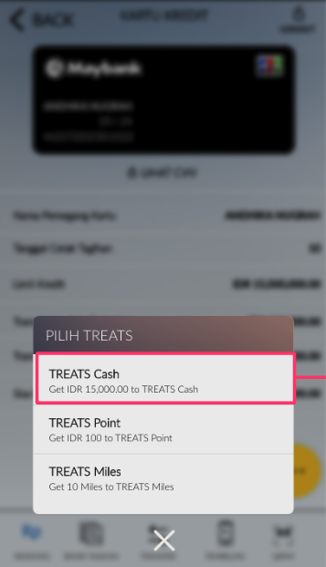 | - Pilih TREATS  - TREATS Cash  - TREATS Points  - TREATS Miles  PILIH TREATS  TREATS Cash  Get IDR XXX,XXX,XXX to TREATS Cash  TREATS Points  Get XXX,XXX,XXX to TREATS Points  TREATS Miles  Get XXX,XXX,XXX Miles to TREATS Miles | - Choose TREATS  - TREATS Cash  - TREATS Points  - TREATS Miles  TREATS SELECTION  TREATS Cash  Get IDR XXX,XXX,XXX to TREATS Cash  TREATS Points  Get XXX,XXX,XXX to TREATS Points  TREATS Miles  Get XXX,XXX,XXX Miles to TREATS Miles
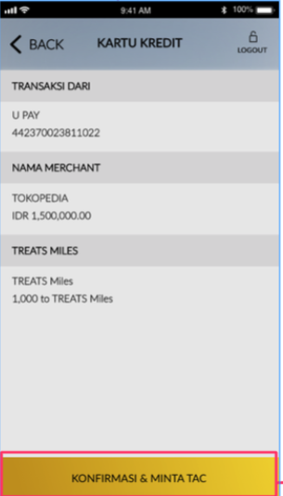 | - Transaksi Dari  - Nama Merchant  - XXX,XXX,XXX ke TREATS Cash/Points/Miles  - KONFIRMASI & MINTA TAC | - Transaction From  - Merchant Name  - XXX,XXX,XXX to TREATS Cash/Points/Miles  - CONFIRM & REQUEST TAC
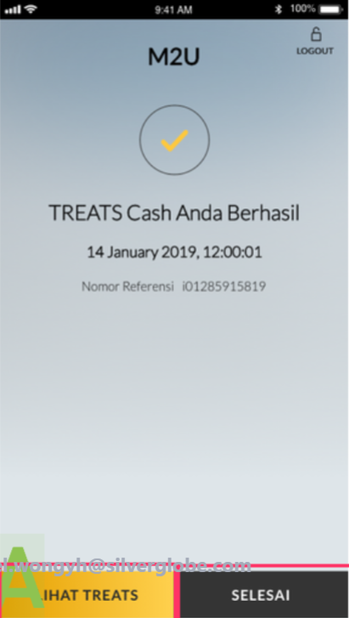 | - TREATS [Cash/Points/Miles] Anda Berhasil  - Nomor Referensi  - LIHAT TREATS  - SELESAI | - TREATS [Cash/Points/Miles] is Successful  - Reference Number  - MY TREATS  - DONE
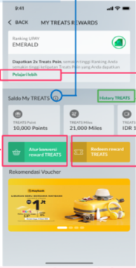 | - My TREATS Rewards  - Ranking Kartu Kredit  - Tingkatkan transaksi Anda dan kumpulkan lebih banyak TREATS sebagai benefit kenaikan Ranking Anda  Pelajari Lebih  - Saldo My TREATS  - History TREATS  - TREATS Points  - TREATS Miles  - TREATS Cash  - Atur Konversi TREATS  - Tukarkan TREATS | - My TREATS Rewards  - Credit Card Ranking  - Spend more and earn more TREATS as your Ranking Benefits  Learn More  - My TREATS Balance  - TREATS History  - TREATS Points  - TREATS Miles  - TREATS Cash  - TREATS Conversion Setting  - TREATS Redemption
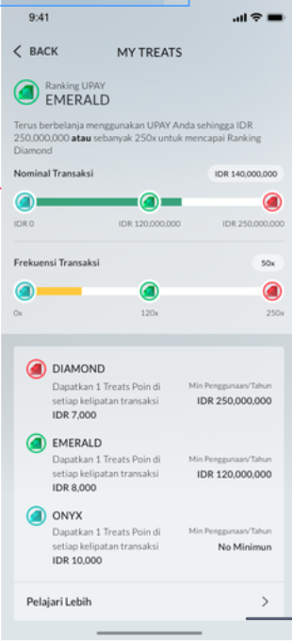 | - Ranking Kartu Kredit  - Terus berbelanja menggunakan Kartu Kredit Anda sesuai Nominal Transaksi, atau Frekuensi Transaksi di bawah, dan kumpulkan lebih banyak TREATS sebagai benefit kenaikan Ranking Anda  - Nominal Transaksi  - Frekuensi Transaksi  - Dapatkan TREATS Points / TREATS Cash / TREATS Miles di setiap kelipatan transaksi [IDR 7,000/8,000/10,000]  - Min Penggunaan/Tahun  [IDR 250,000,000 ATAU 250x transaksi /  IDR 120,000,000 ATAU 120x transaksi /  No Minimum]  - Pelajari Lebih | - Credit Card Ranking  - Spend more using your Credit Card to achieve below Transaction Amount, or Transaction Frequency, and collect more TREATS as your Ranking Benefits  - Transaction Amount  - Transaction Frequency  - Get TREATS Points / TREATS Cash / TREATS Miles [IDR 7,000/IDR 8,000/IDR 10,000] in each transaction  - Min Spend/Year  [IDR 250,000,000 OR 250x transactions /  IDR 120,000,000 OR 120x transactions /  No Minimum]  - Learn More
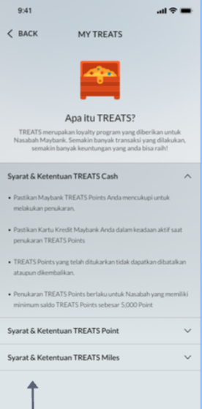 | [Diatur melalui Back Office] | [Diatur melalui Back Office]
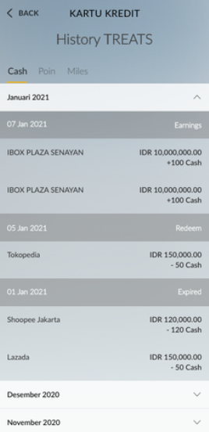 | - History TREATS  - Cash | Point | Miles  - Earnings | Redeem | Expired | - TREATS History  - Cash | Point | Miles  - Earnings | Redeem | Expired
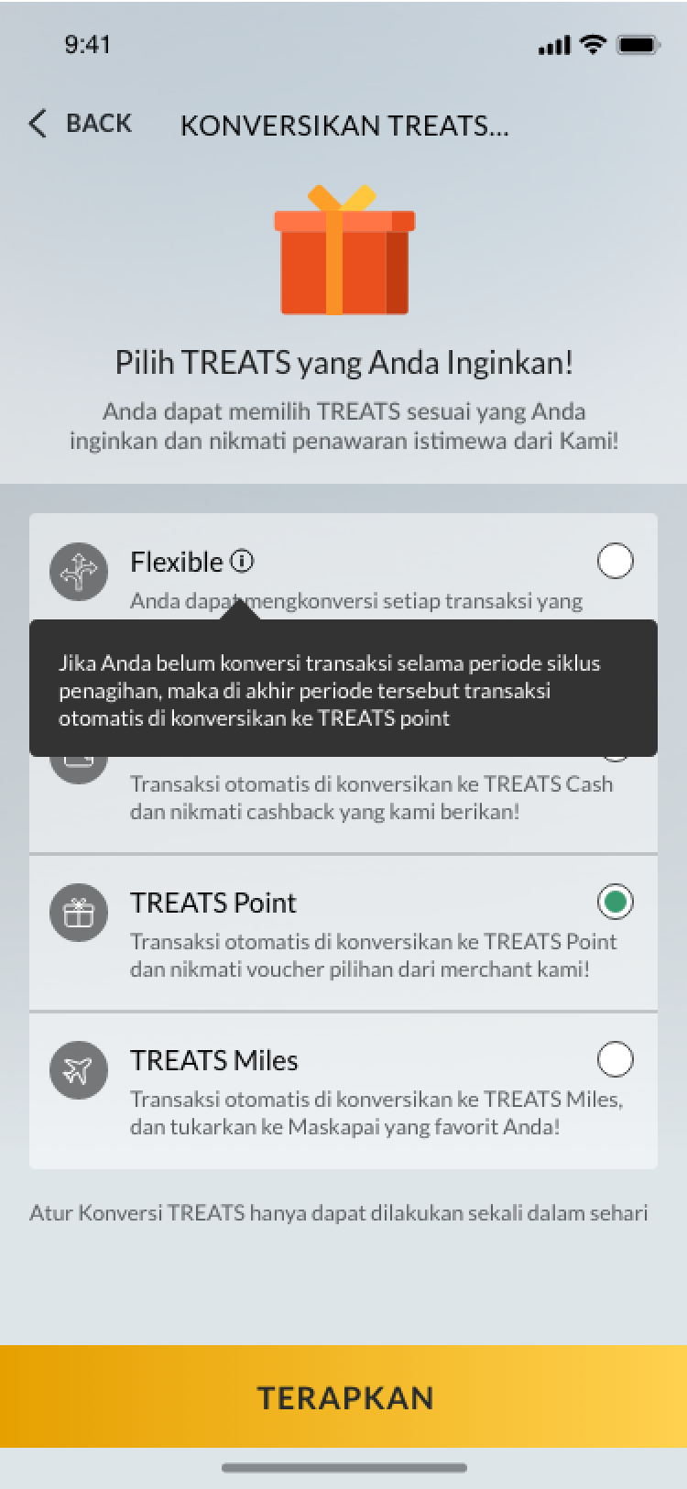 | - Konversikan TREATS Anda  - Pilih TREATS yang Anda Inginkan!  - Anda dapat memilih TREATS sesuai yang Anda inginkan dan nikmati penawaran istimewa dari kami!  - Flexible  Setiap transaksi yang Anda lakukan dapat dikonversi menjadi TREATS Cash/TREATS Points/TREATS Miles sesuai yang diinginkan!  - [Tooltip Flexible]  Jika Anda belum melakukan pemilihan jenis TREATS atas transaksi yang terjadi hingga akhir periode siklus penagihan, maka transaksi tersebut akan otomatis terkonversi ke TREATS Cash  - TREATS Points  Setiap transaksi yang Anda lakukan dengan konversi jenis TREATS Points, dapat ditukarkan ke berbagai voucher dan barang pilihan Anda!  - TREATS Miles  Setiap transaksi yang Anda lakukan dengan konversi jenis TREATS Miles ke berbagai airlines miles!  - TREATS Cash  Setiap transaksi yang Anda lakukan dengan konversi jenis TREATS Cash, nikmati cashback nya!  - Atur konversi TREATS hanya dapat dilakukan sekali dalam sehari  - TERAPKAN | - Convert Your TREATS  - Select the TREATS You Want!  - Choose TREATS that you want and enjoy special offers from us!  - Flexible  Every transaction you make can be converted into TREATS Cash/TREATS Points/TREATS Miles as wish!  - [Tooltip Flexible]  If you haven’t converted the transactions at the end of each billing cycle period, transactions will be auto converted into TREATS Cash  - TREATS Points  Every transaction that you make with the TREATS Points type conversion, can be redeem for various vouchers and items of your wish!  - TREATS Miles  Every transaction you make with TREATS Miles type conversion to various airlines miles!  - TREATS Cash  Every transaction you make with a TREATS Cash type conversion,  enjoy the cashback!  - TREATS Conversion Setting can only be done once a day  - APPLY
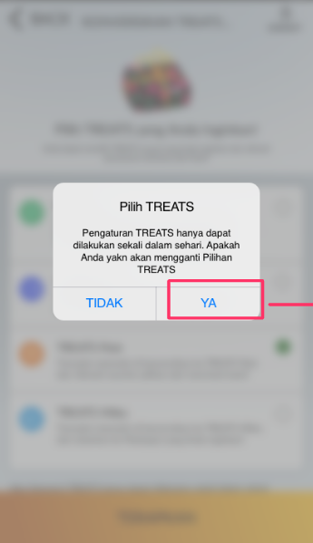 | - Pilih TREATS  - Pengaturan TREATS hanya dapat dilakukan sekali dalam sehari. Apakah Anda yakin akan mengganti pilihan TREATS?  - YA / TIDAK | - Select TREATS  - TREATS Conversion Setting can only be done once a day. Are you sure you want to change the TREATS option?  - YES / NO
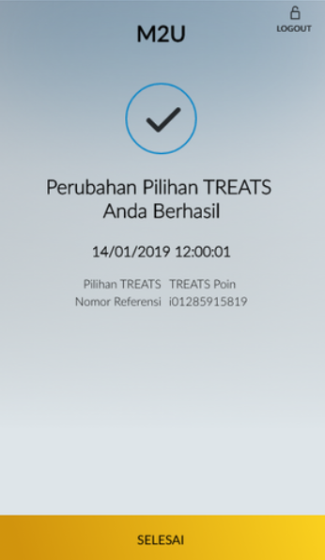 | - Perubahan Pilihan TREATS Anda Berhasil  - Pilihan TREATS  - Nomor Referensi | - Your TREATS Option Change Successful  - TREATS Option  - Reference Number
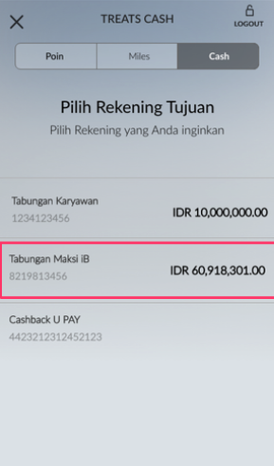 | - TREATS CASH  - Point  - Miles  - Cash  - Pilih Rekening Tujuan  - Pilih Rekening yang Anda inginkan | - Treats Cash  - Point  - Miles  - Cash  - Select Destination Account  - Select Account You want
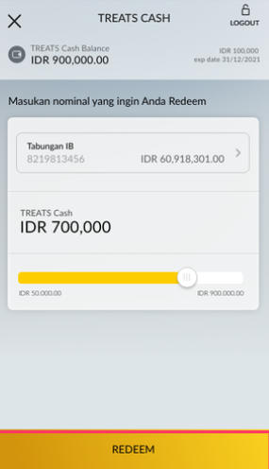 | - Saldo TREATS Cash  - exp date  - Masukkan nominal yang ingin Anda Redeem  - REDEEM | - TREATS Cash Balance  - exp date  - Enter the amount you want to Redeem  - REDEEM
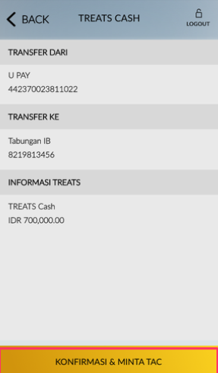 | - Transfer Dari  - Transfer Ke  - Informasi TREATS | - Transfer From  - Transfer To  - TREATS Information
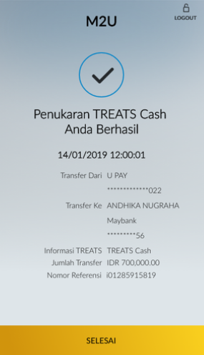 | - Penukaran TREATS Cash Anda Berhasil  - Transfer Dari  - Transfer Ke  - Informasi TREATS  - Jumlah Transfer  - Nomor Referensi | - Your TREATS Cash Exchange is Successful  - Transfer From  - Transfer To  - TREATS Information  - Transfer Amount  - Reference Number
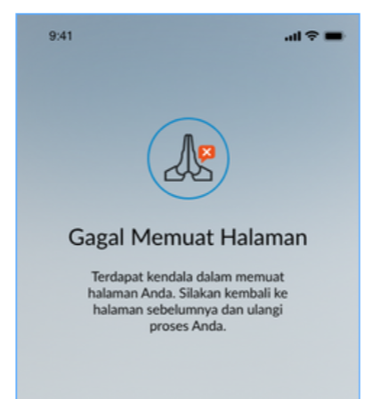 | Gagal Memuat Halaman  Terdapat kendala dalam memuat halaman Anda. Silakan kembali ke halaman sebelumnya dan ulangi proses Anda. | Failed to Load  Unable to load your page. Please access the previous screen and retry.
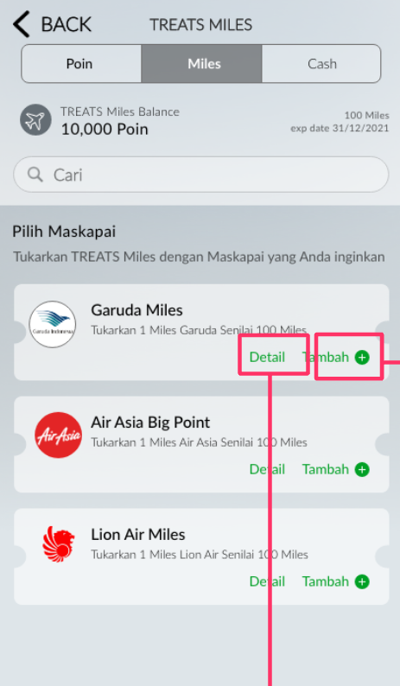 | - TREATS MILES  - Saldo TREATS Miles  - Pilih Maskapai  - Tukarkan TREATS Miles dengan Maskapai yang Anda inginkan  - Tukarkan XXX TREATS Miles dengan xxx Miles [Nama Airline]  - Detil  - Tambah | - TREATS MILES  - TREATS Miles Balance  - Choose an Airline  - Redeem TREATS Miles with the Airline you want  - Exchange XXX TREATS Miles for xxx Miles [Nama Airline]  - Details  - Add
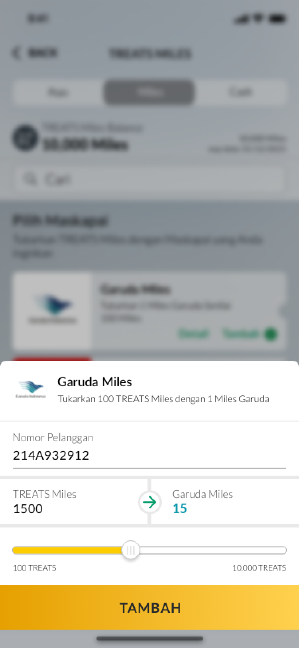 | - Tukarkan XXX TREATS Miles dengan xxx Miles [Nama Airline]  - Nomor Pelanggan  - TREATS Miles | [Airline] Miles  - xxx TREATS  - TAMBAH | - Exchange xxx TREATS Miles for xxx Miles [Nama Airline]  - Customer Number  - TREATS Miles | [Airline] Miles  - xxx TREATS  - ADD
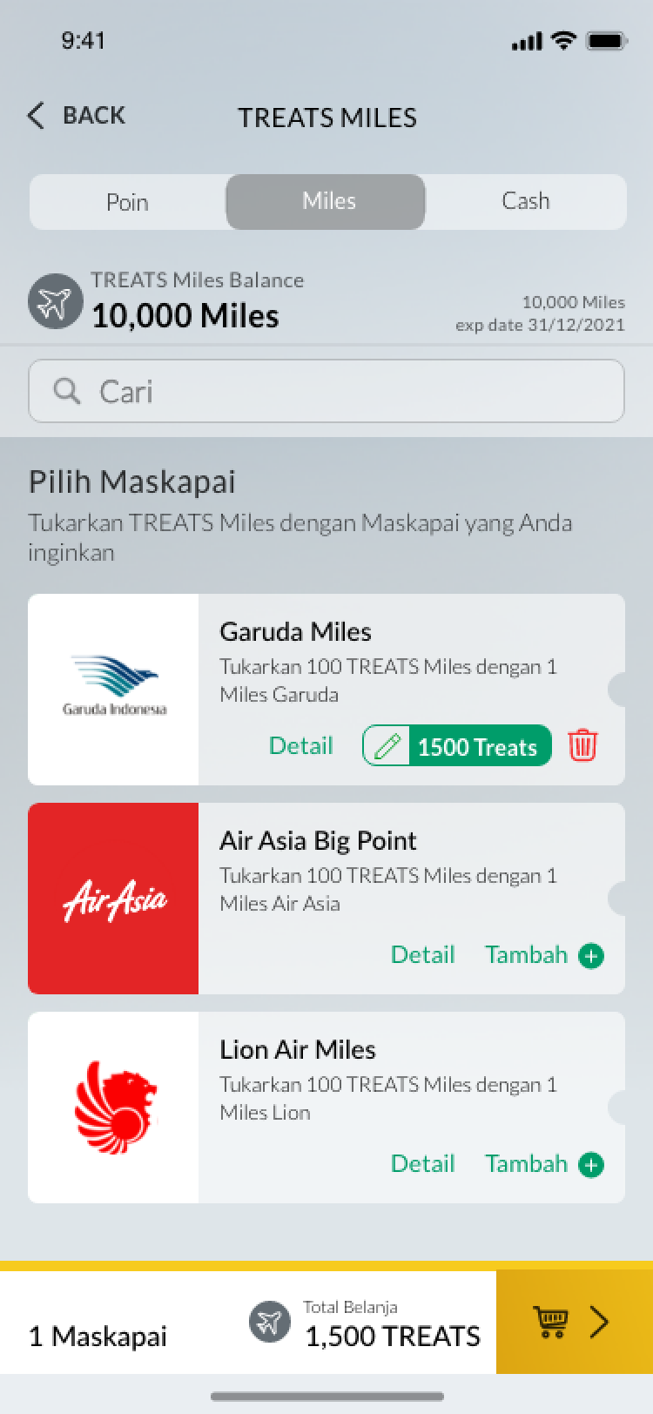 | - X maskapai  - Total Belanja | - X Airlines  - Shopping Total
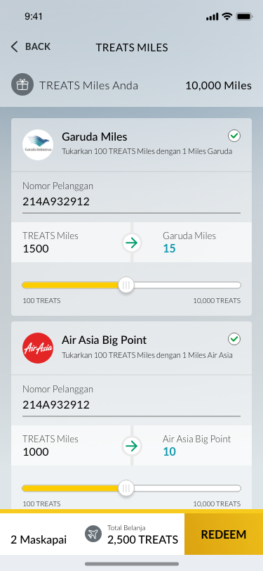 | - TREATS Miles Anda  - REDEEM | - Your TREATS Miles  - REDEEM
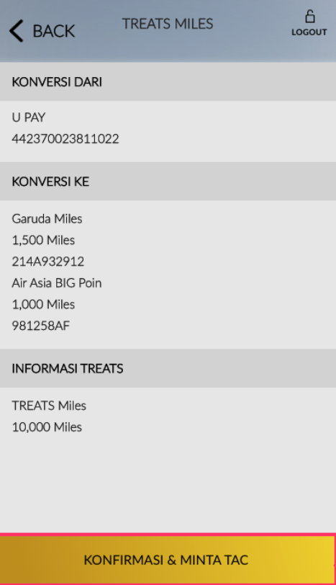 | - Konversi Dari  - Konversi Ke  - Informasi TREATS | - Redeem From  - Redeem To  - TREATS Information
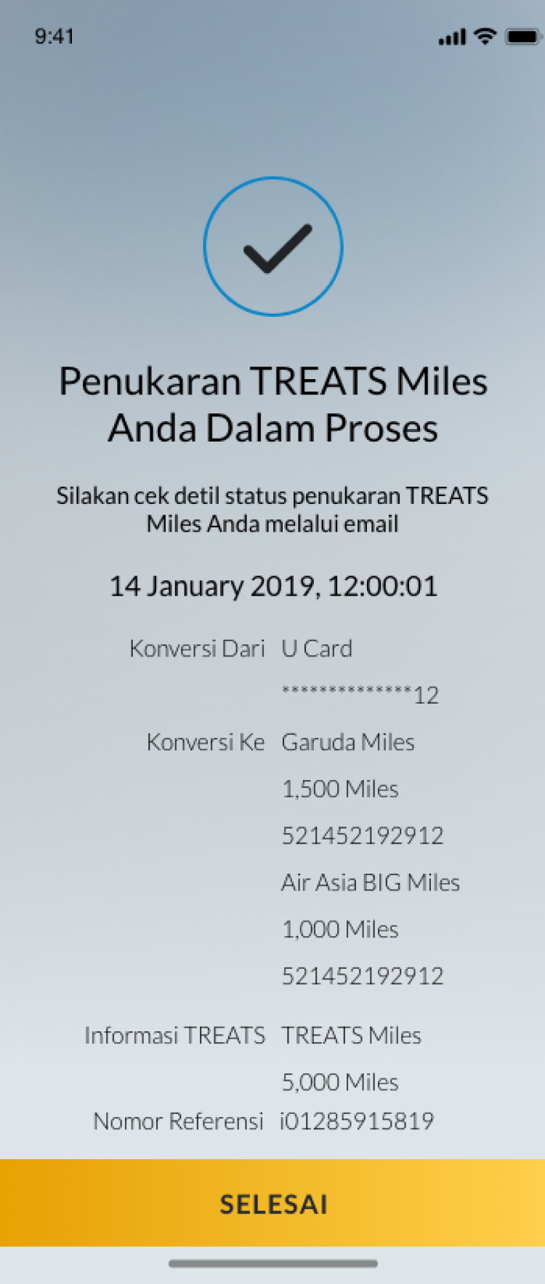 | - Penukaran TREATS Miles Anda dalam Proses  - Silakan cek detil status penukaran TREATS Miles Anda melalui email  - Konversi Dari  - Konversi Ke  - Informasi TREATS  - Nomor Referensi  - SELESAI | - Your TREATS Miles Redemption is in Progress  - Please check your TREATS Miles redemption status via email  - Redeem From  - Redeem To  - TREATS Information  - Reference Number  - DONE
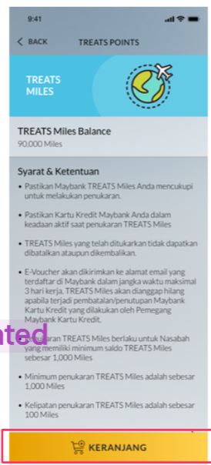 | - TREATS MILES  - Saldo TREATS Miles  - Syarat & Ketentuan  [T&C content depends on back office loyalty]  - KERANJANG | - TREATS MILES  - TREATS Miles Balance  - Terms & Conditions  [T&C content depends on back office loyalty]  - CART
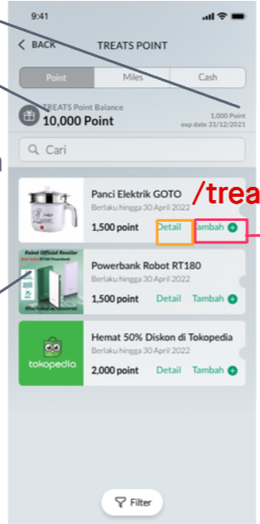 | Vouchers content depends on merchant  - TREATS POINTS  - Saldo TREATS Points  - Xxx Point  - Exp date  - Cari  - Detil  - Tambah | Vouchers content depends on merchant  - TREATS POINTS  - TREATS Points Balance  - Xxx Point  - Exp date  - Search  - Detail  - Add
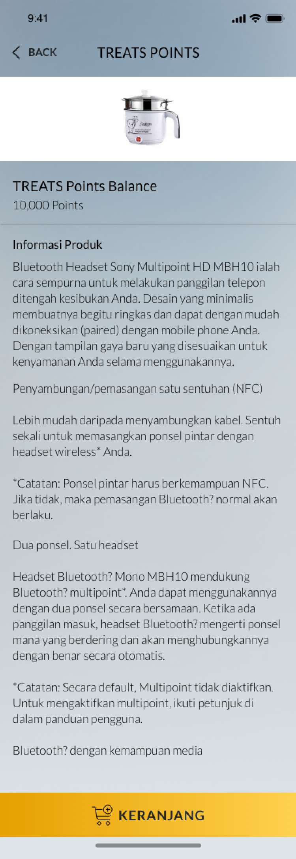 | - TREATS POINTS  - Saldo TREATS Points  - Informasi Produk  [T&C content depends on back office loyalty]  - KERANJANG | - TREATS POINTS  - TREATS Points Balance  - Product Information  [T&C content depends on back office loyalty]  - CART
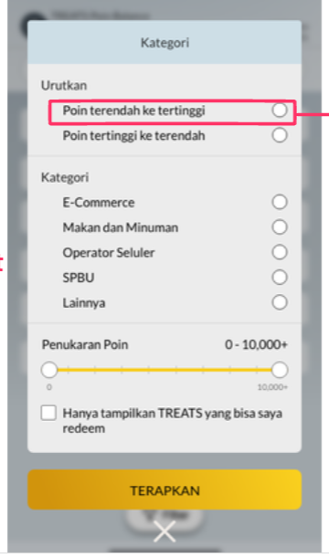  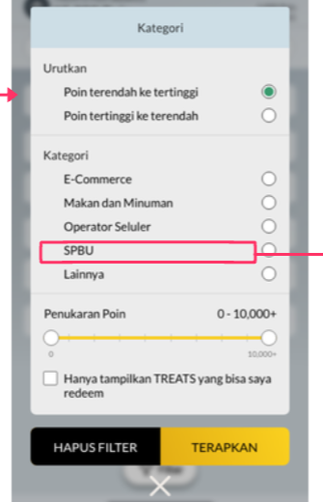 | - Kategori  - Urutkan  - Poin terendah ke tertinggi  - Poin tertinggi ke terendah  - Kategori  [depend on category from BO Loyalty]  - Penukaran Poin  - Hanya tampilkan TREATS yang bisa saya redeem  - Hapus Filter  - Terapkan | - Categories  - Sort  - Lowest to highest points  - Highest points to lowest  - Categories  [depend on category from BO Loyalty]  - Points Redemption  - Only show TREATS that I can redeem  - Filter Reset  - Apply
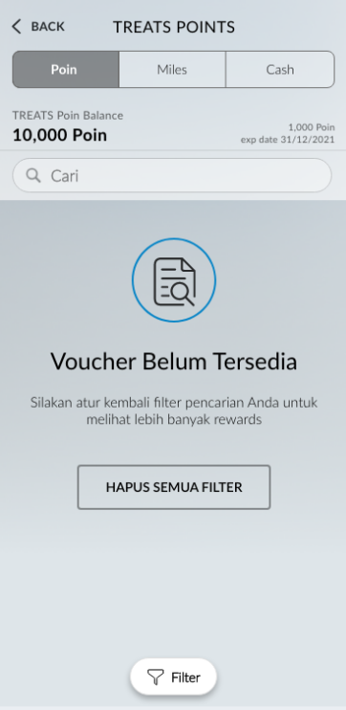 | - Voucher Belum Tersedia  - SIlakan atur kembali filter pencarian Anda untuk melihat lebih banyak rewards  - HAPUS SEMUA FILTER | - Vouchers Not Available  - Please reset your search filter to see more rewards  - RESET FILTERS
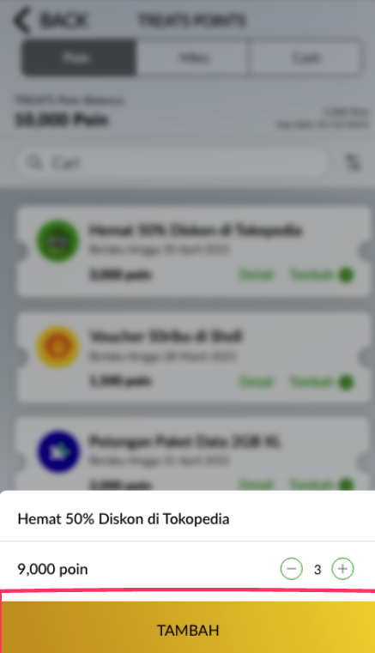 | - Tambah | - Add
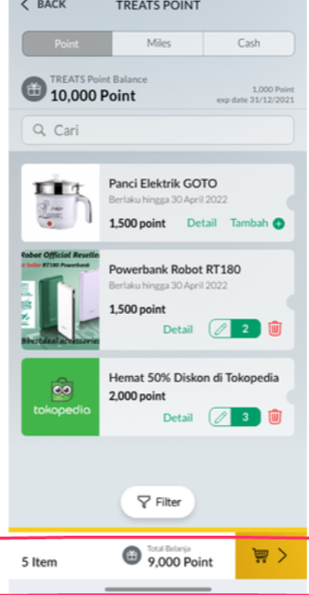 | - N Item  - Total Belanja | - N Item(s)  - Shopping Total
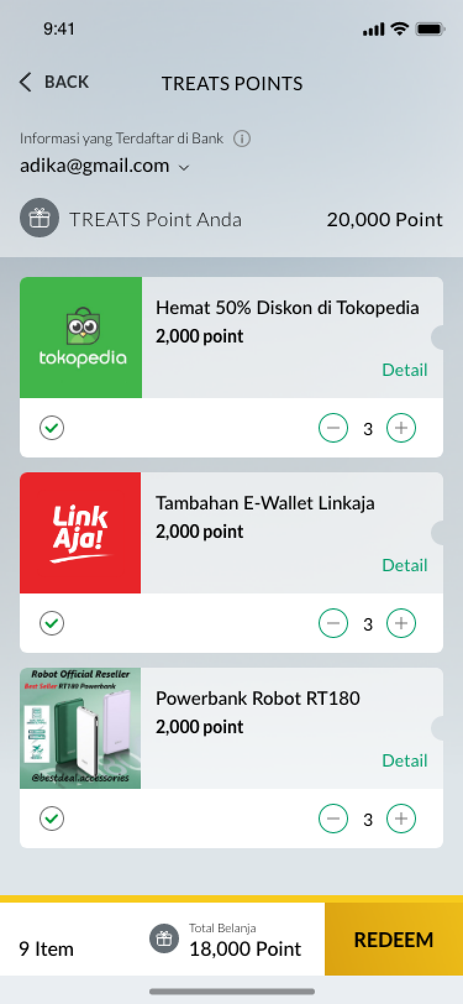  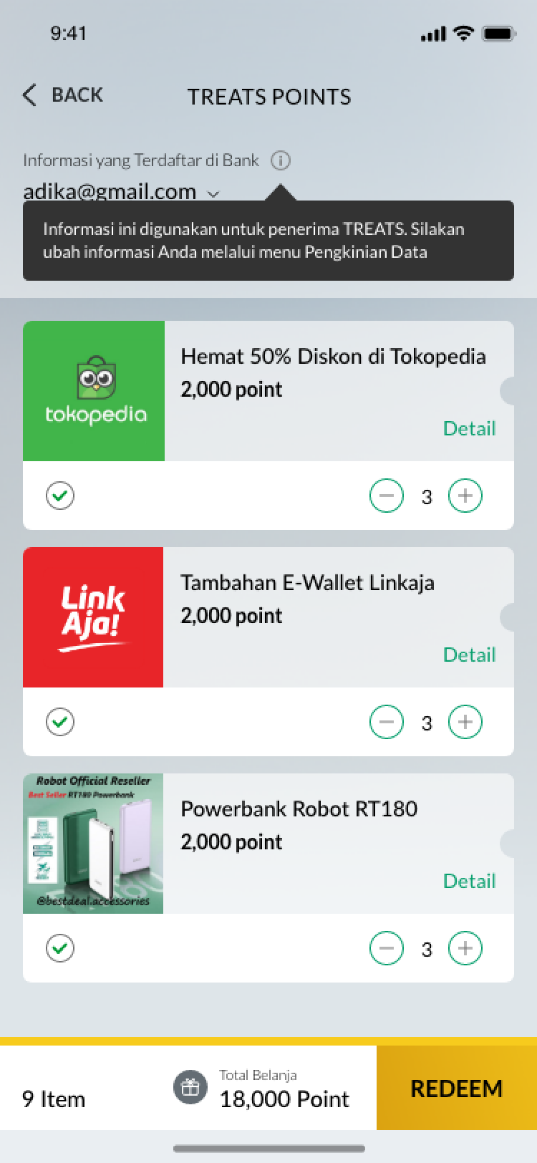 | - Informasi Anda yang Terdaftar di Bank  - TREATS Points Anda  - … Point  - [Tooltip]  Informasi Anda digunakan untuk penerima TREATS. Silakan ubah informasi Anda melalui menu Pengkinian Data | - Your Registered Information at Bank  - Your TREATS Points  - …. Point  - [Tooltip]  Your information will be used as the source of TREATS recipient. Please change your information through Customer Profile Update menu.
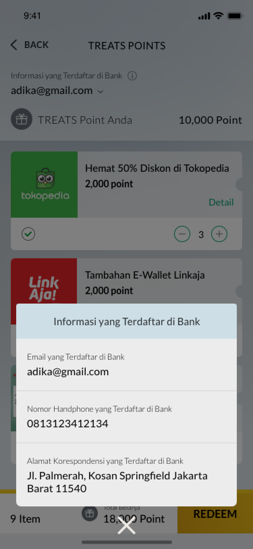 | - Email yang Terdaftar di Bank  - Nomor Handphone yang Terdaftar di Bank  - Alamat Korespondensi yang Terdaftar di Bank | - Registered Email at the Bank  - Registered Phone Number at the Bank  - Registered Address at the Bank
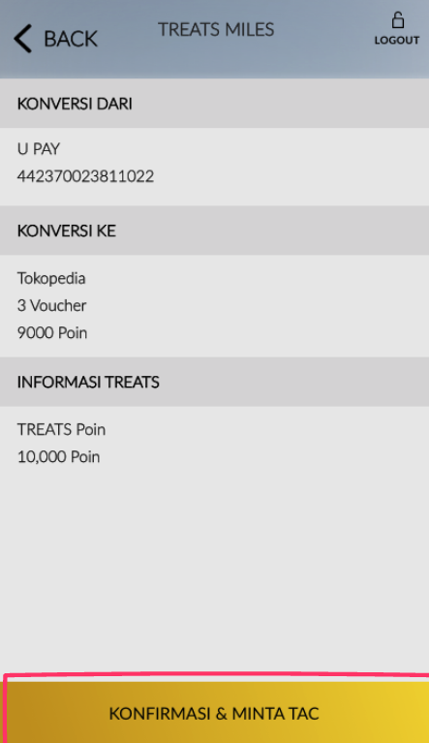 | - Konversi Dari  - Konversi Ke  - [Product name]  - … Item  - … Point  - Informasi TREATS  - TREATS Points  - …. Point | - Redeem From  - Redeem To  - [Product name]  - … Item  - … Point  - TREATS Information  - TREATS Points  - …. Point
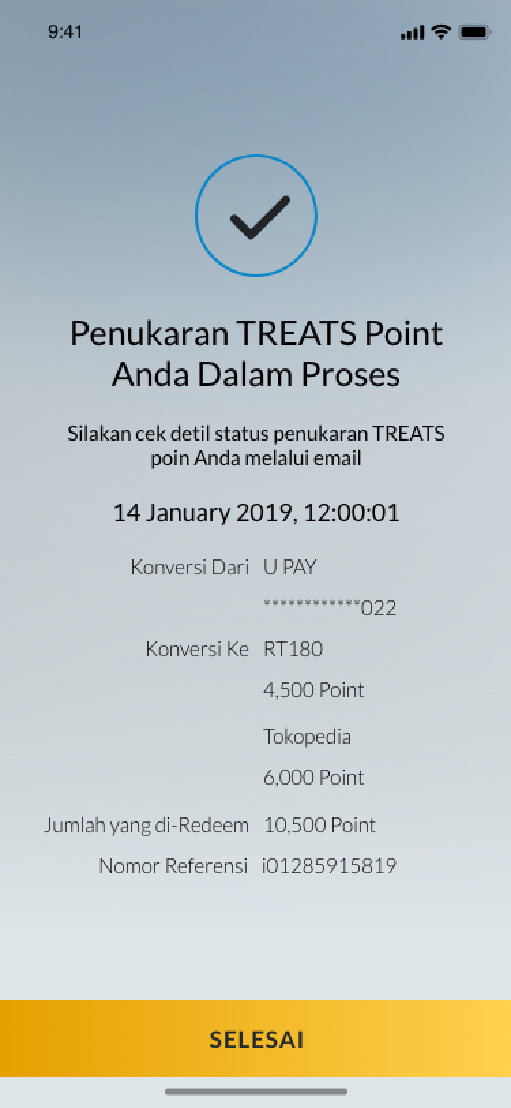 | - Penukaran TREATS Points Anda Dalam Proses  - Silakan cek detil status penukaran TREATS Points Anda melalui email  - Konversi Dari  - Konversi Ke  - [Product name]  - … Point  - Jumlah yang di-Redeem  - …. Point  - Nomor Referensi  - SELESAI | - Your TREATS Points Redemption is in Progress  - Please check your TREATS Points redemption status via email  - Redeem From  - Redeem To  - [Product name]  - …. Point  - Redemption Amount  - …. Point  - Reference Number  - DONE
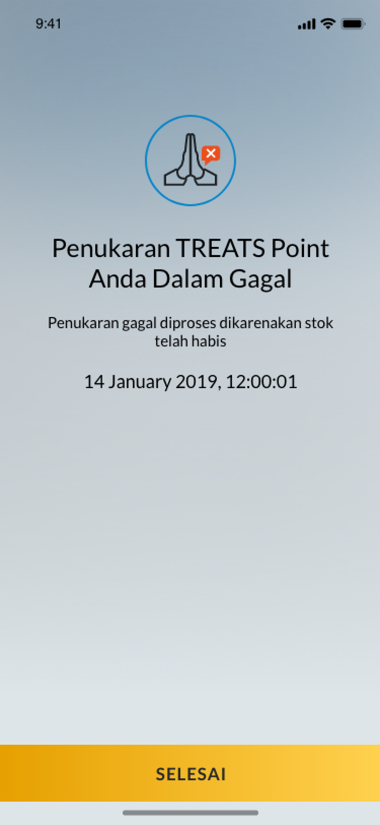 | - Penukaran TREATS Points Anda Gagal  - Penukaran gagal diproses dikarenakan stok telah habis  - SELESAI | - Your TREATS Points Redemption is Unsuccessful  - Redemption is unsuccessful due to stock unavailability  - DONE

