# Migrate to the HTTP v1 API

Caution: Sending messages (including upstream messages) with the FCM XMPP and HTTP legacy APIs was deprecated on June 20, 2023, and **will be removed in June 2024.**

## HTTP request

* It is versioned, with /v1 in the path
* The path contains the project ID of the Firebase project for your app, in the format /projects/myproject-ID/
* Its explicitly is to have specific of Send Method as :send

### HTTP requests before

POST <https://fcm.googleapis.com/fcm/send>

### HTTP requests after

POST <https://fcm.googleapis.com/v1/projects/myproject-b5ae1/messages:send>

### Changes

* Need define project ID of the Firebase Project in PNS
* Change base URL FCM at PNS Source code.

### How to find out Project ID

* Open <https://console.firebase.google.com/project/_/settings/serviceaccounts/adminsdk>
* To locate Project ID

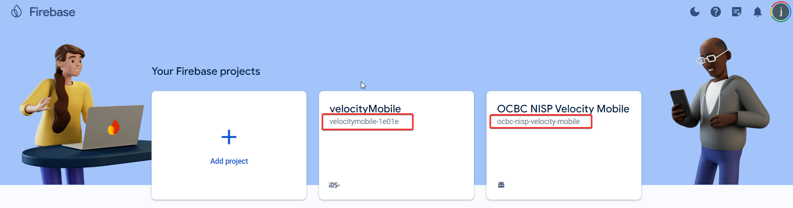

## Authorization

### Auth before

Authorization: key=AIzaSyZ-1u...0GBYzPu7Udno5aA

### Auth after

Authorization: Bearer ya29.ElqKBGN2Ri_Uz…0HwUda

### Changes

* Change code PNS when build request to firebase.
* Token generated without google library because Java version current PNS code is 1.6. (Not support google library)
* Minimum version support Google Library is Java version 1.8.
* Alternatively need to manual generate token with private key and email service account (all information in service account JSON file)

### How to find out Service Account JSON

* Open <https://console.firebase.google.com/project/_/settings/serviceaccounts/adminsdk>
* Find out Project used and click to see details.

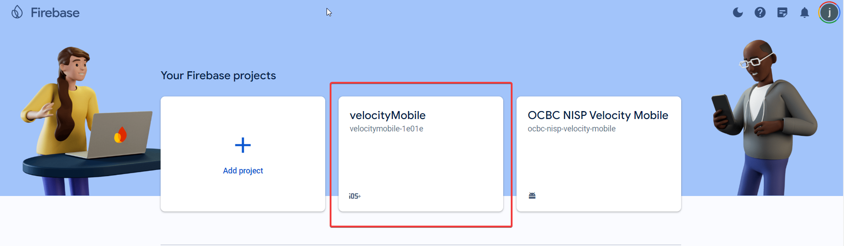

* Under tab service account, click generate new private key.

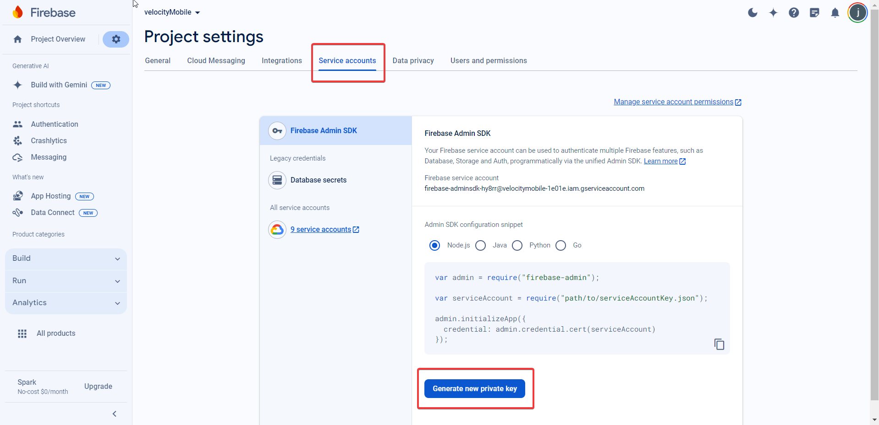

**Remark:**

***May need OCBC Team to download the Private Key from Production FCM for both iOS and Android and share to Silverlake for before Production deployment.***

## Payload of send request.

FCM HTTP v1 introduces a significant change in the structuring of the JSON message payload. Primarily, these changes ensure that messages are managed correctly when received on different client platforms; additionally, the changes give you extra flexibility to customize, or "override" message fields per platform.

### Payload before

{  
  "notification": {  
    "title": "Breaking News",  
    "body": "New news story available."  
  },  
  "data": {  
    "refNo": "78278bde-000d",

    "type": "",

    "template": "template"   
  },

  "registration_ids": ["dRCC660…J1gCae"]  
}

### Payload after

{  
  "message": {  
    "topic": "news",  
    "notification": {  
      "title": "Breaking News",  
      "body": "New news story available."  
    },  
    "data": {  
      "story_id": "story_12345"  
    }  
  }  
}

### Payload targeting multiple platforms.

{  
  "message": {  
    "topic": "news",  
    "notification": {  
      "title": "Breaking News",  
      "body": "New news story available."  
    },  
    "data": {  
      "story_id": "story_12345"  
    },  
    "android": {  
      "notification": {  
        "click_action": "TOP_STORY_ACTIVITY"  
      }  
    },  
    "apns": {  
      "payload": {  
        "aps": {  
          "category" : "NEW_MESSAGE_CATEGORY"  
        }  
      }  
    }  
  }  
}

### Changes

* Change code PNS when build request to firebase.

# Full information PNS new payload when hitting firebase.

curl --location 'https://fcm.googleapis.com/v1/projects/velocitymobile-1e01e/messages:send' \

--header 'Content-Type: application/json' \

--header 'Authorization: Bearer ya29.c.c0AY_VpZjHQ_1BQiX6OUh_h1pUfO9uvRc9ICXGYvIn7oSvZQbTxmjE6RIjXCTJZ-kKr7zh3lQDBrLasy8spf6hVznQ66gduizFaHhD_Tn7WHbPuQn7oy6VmM_Yp5ueGSj7sYRQQI0LhFlzO845wLFF1KdHotFCx57greKJQEmiNW_dlW7xfZr9Y022B1VdQsEMVhMH2xSIHKNMKqAed4Dx01nEccmRWTOi0hPJwuPfSFZGoLuRhWYssqUp2JSCLfW3LnnidpbrysLlgz-P_FZLtDl82e-Kd_3BoBij62sPNb57Z_9xktxuTegFvnTcsoXgwpFPFrdyp_wVo-xhmHs-LRNeJ9hHwDYrHC0rkVWLVr85I81RFpzBJWDwN385A6yua3rsJSRbfMSvi3F02ZxwcMWWmXamvhB_mb48ilzQcSSwrFRBfmw6t95U1z20ya2MFl2M7jrdSUfn2Jq3g9kx_e8OSUhWqtsUR1B3di0M2015quWJe6FRJlxY4WZMuIkkd_ousYjZFnpXxes334twRjp8nSjl2dXlx5Shcjqsf8nRo8UrqtXQon0s3lIncQZykkel2oaUqcZQQwZF5VvfJ7gf3OSupMik-o2vzaY3WVBflupeJnaUrWp6ca4ekdhbnsBk4Biby-jSI_aUbwspi39rB9jRkwvksSpxziso5Z4zItqQSV55ypg-ue-7Rg07RI7FhvvqYpu1V5ntJdySMWm9BzBrZRbIzf_s9q5U5q3euh_Swqz9O0uSgZp5dYWYJM72vZ_UW992Z3sRYzcl55-sid38IpgoWkg7cnQy8J0ojmj614XzRWklh5WksaXxkVgZ_J1U2-azxbvWghc0ZX0UxO7bUR0ttSbc8cs6Q8Z9lniukfzrIfYMOn9llq_jVmwzMv67yF3qYx0dYq7_4oZbjkz3itd647yM1cJjZ6dw1XJ9-J0Ml2YfUFSvj7iv-IQVp9wFono-9x5kdSttdn0ZSk8cpv-uk7Zsq67SIFSb6nIW7y9eRw3' \

--data '{

"message": {

"token": "dRC660XhUENrqeJ1glkrbR:APA91bFr9tfkFaSL24rpg8sCTVVs38wgwlZcYgc3y5OoRYMlX5xShblJVa-fixXIA6_yzIFgpyjsOB85bA-XkPFql8SN9n7f5xr5DlvN5GcjMmEF19I8kDAw2VYFBK3pPu5CeQO4MCae",

"data": {

"refNo": "ef00b2ab-c548-490e-b9b7-33b339d584b9"

},

"notification": {

"body": "You bound iPhone 13 Pro to OCBC Business mobile. Please login to check your bound device",

"title": ""

}

}

}'

*Note: This bearer token has a short lifespan so it cannot be used forever, which needs to generate new tokens if it expires.*