OCBC Velocity Chinese Language

Functional Specifications Document

Velocity Mobile Banking

**Confidentiality**

This document contains proprietary information that is confidential to OCBC NISP. Disclosure of this document in full or in part, may result in material damage to OCBC NISP. Written permission must be obtained from OCBC NISP prior to the disclosure of this document to third party.

PREFACE

***Purpose***

This Functional Specification Document (FSD) describes Velocity Mobile Banking features and system flow.

This document will form the final requirements for the development activities such as design, customization, and testing and implementation of Velocity Mobile Bankingfeatures and system flow.

***Document Change Control***

|  |  |  |  |
| --- | --- | --- | --- |
| **Version** | **Date** | **Authors** | **Summary of Changes** |
| 0.1 | 21st May 2025 | Yap Chek Ying |  |
|  |  |  |  |
|  |  |  |  |
|  |  |  |  |
|  |  |  |  |

***Reference Document***

|  |  |  |
| --- | --- | --- |
| **No** | **Document Name** | **Authors** |
| 1 |  |  |
|  |  |  |

***Table of Contents***

1 Introduction 3

**1.1** **Supported Devices & OS Version** 3

2 Functional Specification 4

**2.1** **Chinese Language** 4

2.1.1 General Description of Functionality 4

**2.2** **Process Flow for Chinese Language** 5

**2.3** **User Interface** 6

***Table of Figures***

Figure 1 Chinese Language Process Flow 5

Figure 2 Select Chinese Language Access Point 6

# Introduction

This Functional Specification Document has been setup with the objective of enhancing Velocity Mobile (hereinafter to be referred as “VM”) to show in Chinese language.

More details and processes with screen designs are shown in this document.

* 1. **Supported Devices & OS Version**

The VM App will be supported on the following Mobile OS:-

| **Mobile OS** | **Remarks** |
| --- | --- |
| Android | 5 and above |
| iOS | 12.4 and above |

***\*Jail broken / rooted devices are not Supported.***

*Note: All screen designs shown in this document is for illustration purpose only. Screen design may differ during the development phase.*

# Functional Specification

* 1. **Chinese Language**

VM users have the option to switch the interface to Chinese language.

### General Description of Functionality

1. To begin, customer would access to Languages by enter the Settings from Side Menu and click Languages.
2. Customer will navigate to Language screen.
3. “中文” will appear in the language selection menu to represent Chinese.
4. When the customer selects “中文” and taps the 'USE THIS LANGUAGE' button, the app interface will switch to Chinese.
   1. **Process Flow for Chinese Language**

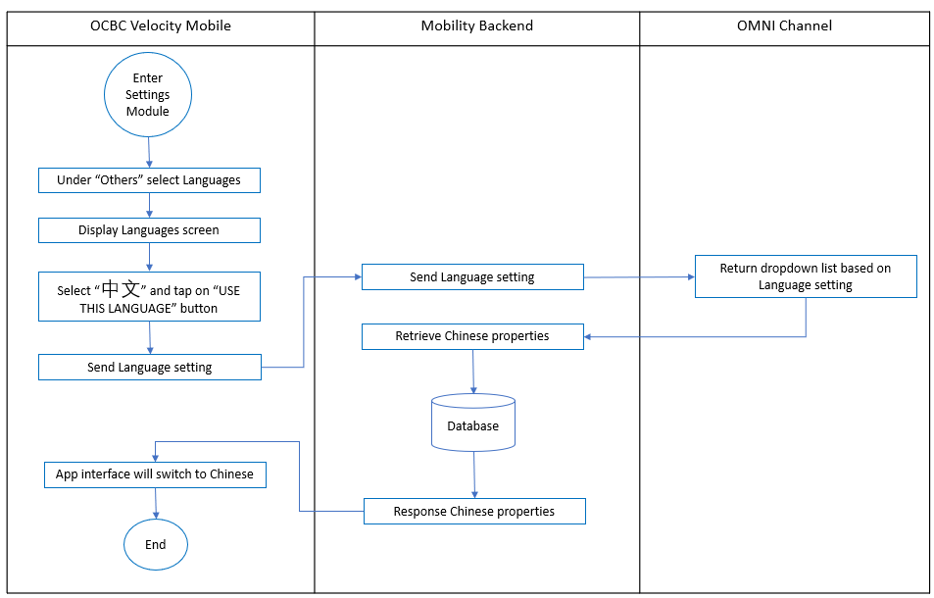

Figure 1 Chinese Language Process Flow

* 1. **User Interface**

This feature allows users have the option to switch the interface to Chinese language.

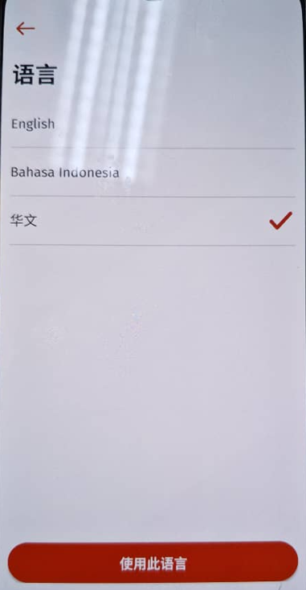

Figure 2 Select Chinese Language Access Point

|  |  |  |  |  |  |
| --- | --- | --- | --- | --- | --- |
| **No** | **Field Name** | **Data Type** | **M\*** | **Length** | **Remarks/ Validation** |
|  |  | Icon | - |  | Navigate user to previous screen, Settings Screen |
|  | English | Button | - |  | Language option |
|  | Bahasa Indonesia | Button | - |  | Language option |
|  | 中文 | Button | - |  | Language option |
|  |  | Icon | - |  | Show on the right side of selected language |
|  | USE THIS LANGUAGE | Button | - |  | Navigate to Home screen with selected language |