OCBC Velocity Time Deposit On Call (Day)

Functional Specifications Document

Velocity Mobile Banking

**Confidentiality**

This document contains proprietary information that is confidential to OCBC NISP. Disclosure of this document in full or in part, may result in material damage to OCBC NISP. Written permission must be obtained from OCBC NISP prior to the disclosure of this document to third party.

PREFACE

***Purpose***

This Functional Specification Document (FSD) describes Velocity Mobile Banking features and system flow.

This document will form the final requirements for the development activities such as design, customization, and testing and implementation of Velocity Mobile Bankingfeatures and system flow.

***Document Change Control***

|  |  |  |  |
| --- | --- | --- | --- |
| **Version** | **Date** | **Authors** | **Summary of Changes** |
| 0.1 | 28th August 2025 | Yap Chek Ying |  |
|  |  |  |  |
|  |  |  |  |
|  |  |  |  |
|  |  |  |  |

***Reference Document***

|  |  |  |
| --- | --- | --- |
| **No** | **Document Name** | **Authors** |
| 1 |  |  |
|  |  |  |

***Table of Contents***

1 Introduction 3

**1.1** **Supported Devices & OS Version** 3

2 Functional Specification 4

**2.1** **Time Deposit On Call (Day)** 4

2.1.1 General Description of Functionality 4

**2.2** **Process Flow for Time Deposit On Call (Day)** 6

**2.3** **User Interface** 9

2.3.1 Open Time Deposit On Call (Day) Account 9

2.3.2 Account Summary 16

2.3.3 Authorization 18

2.3.4 Task List 22

2.3.5 Transaction Summary 25

***Table of Figures***

Figure 1 Time Deposit On Call (Day) Process Flow 5

Figure 2 Time Deposit On Call (Day) Process Flow 5

Figure 3 Time Deposit On Call (Day) Process Flow 6

Figure 4 Time Deposit On Call (Day) Process Flow 6

Figure 5 Time Deposit On Call (Day) Process Flow 7

Figure 6 Open Time Deposit On Call (Day) - Access Point 8

Figure 7 Open Time Deposit On Call (Day) - Open New Account Screen 8

Figure 8 Open Time Deposit On Call (Day) - Tenor Type Screen 9

Figure 9 Open Time Deposit On Call (Day) - Currency Listing (Product) Screen 9

Figure 10 Open Time Deposit On Call (Day) - Source of Fund Listing Screen 10

Figure 11 Open Time Deposit On Call (Day) - Time Deposit Screen 11

Figure 12 Open Time Deposit On Call (Day) - Confirm Transaction Screen 12

Figure 13 Open Time Deposit On Call (Day) - Confirm Transaction (PIN) Screen 13

Figure 14 Open Time Deposit On Call (Day) - Transaction Receipt Screen 14

Figure 15 Account Summary – Time Deposit Access Point 15

Figure 16 Account Summary – My Time Deposit Screen 15

Figure 17 Account Summary – Time Deposit Details Screen 16

Figure 18 Authorization – Access Point 17

Figure 19 Authorization – Authorization Screen 17

Figure 20 Authorization – Authorize (Manual) Screen 18

Figure 21 Authorization – Authorize Approve (Manual) Screen 19

Figure 22 Authorization – Authorize Approve (Manual) Screen 20

Figure 23 Task List – Pending Task List Screen 21

Figure 24 Task List – Authorize Approve (Manual) Screen 22

Figure 25 Authorization – Authorize Approve (Manual) Screen 23

Figure 26 Transaction Summary – Manual Transaction Screen 24

Figure 27 Transaction Summary – Receipt Screen 25

# Introduction

This Functional Specification Document has been setup with the objective of enhancing Velocity Mobile (hereinafter to be referred as “VM”):

1. VM users can now create Time Deposit On Call (Day) accounts through the existing “Open New Account” menu.
2. Users can view the Account Summary for Time Deposit On Call (Day) via the "Time Deposit" submenu under "My Accounts".
3. Checkers can approve the creation of Time Deposit On Call (Day) accounts through the "Authorization" menu and "Task List".
4. Users can view the Transaction Summary for Time Deposit On Call (Day) via the "Transaction Summary" submenu under "Transaction".

More details and processes with screen designs are shown in this document.

* 1. **Supported Devices & OS Version**

The VM App will be supported on the following Mobile OS:-

| **Mobile OS** | **Remarks** |
| --- | --- |
| Android | 5 and above |
| iOS | 12.4 and above |

***\*Jail broken / rooted devices are not Supported.***

*Note: All screen designs shown in this document is for illustration purpose only. Screen design may differ during the development phase.*

# Functional Specification

* 1. **Time Deposit On Call (Day)**

VM users allow to create Time Deposit On Call (Day) accounts, which the tenor can be in 7 days, 8 days, 9 days, 10 days, 11 days, 12 days, 13 days or 14 days. Time Deposit On Call (Day) will be available in English, Bahasa Indonesia and Chinese.

### General Description of Functionality

Open New Account

1. To begin, the customer should access ‘Open New Account’ from the side menu.
2. On the ‘Open New Account’ screen, the customer selects ‘Time Deposit’.
3. On the ‘Tenor Type’ screen, select ‘On Call (Days)’.
4. On the ‘Currency’ screen, select the desired product to open.
5. On the ‘Source of Fund’ screen, select the account from which the funds will be sourced.
6. On the ‘Time Deposit’ screen, fill in all mandatory fields and tap the ‘CONTINUE’ button.
7. On the ‘Confirm Transaction’ screen, check the box for ‘I have read and agreed to the Terms and Conditions and Product Info’.
8. On the ‘Confirm Transaction (PIN)’ screen, input the software token.
9. The app will then navigate to the ‘Transaction Receipt’ screen and display the transaction result.

Account Summary

1. From the side menu, select ‘Time Deposit’ under ‘My Accounts’.
2. On the ‘My Time Deposit’ screen, the customer selects the desired Time Deposit On Call (Day) account to view.
3. On the **‘**Time Deposit Details’ screen, the customer can view the details of the selected Time Deposit On Call (Day) account.

Authorization

1. From the side menu, select ‘Authorization’ under ‘Transaction’.
2. On the ‘Authorization’ screen, select ‘Manual’.
3. The customer will be navigated to the ‘Authorize’ screen, which displays the details of the Time Deposit On Call (Day) account opening.
4. The customer is allowed to Approve, Reject, or Revert to Maker for amendment.

Task List

1. At Home screen, select ‘Pending’ under ‘Manual’ Task List.
2. On ‘Pending Task List’ screen, customer will see details of the Time Deposit On Call (Day) account opening.
3. The customer is allowed to Approve, Reject, or Revert to Maker for amendment.

Transaction Summary

1. From the side menu, select **‘**Transaction Summary’ under ‘Transaction’.
2. On the ‘Transaction Summary Available Source’ screen, select ‘Manual’.
3. On the ‘Transaction Summary’ screen, the customer can view the details and transaction result of the Time Deposit On Call (Day) account opening.
   1. **Process Flow for Time Deposit On Call (Day)**

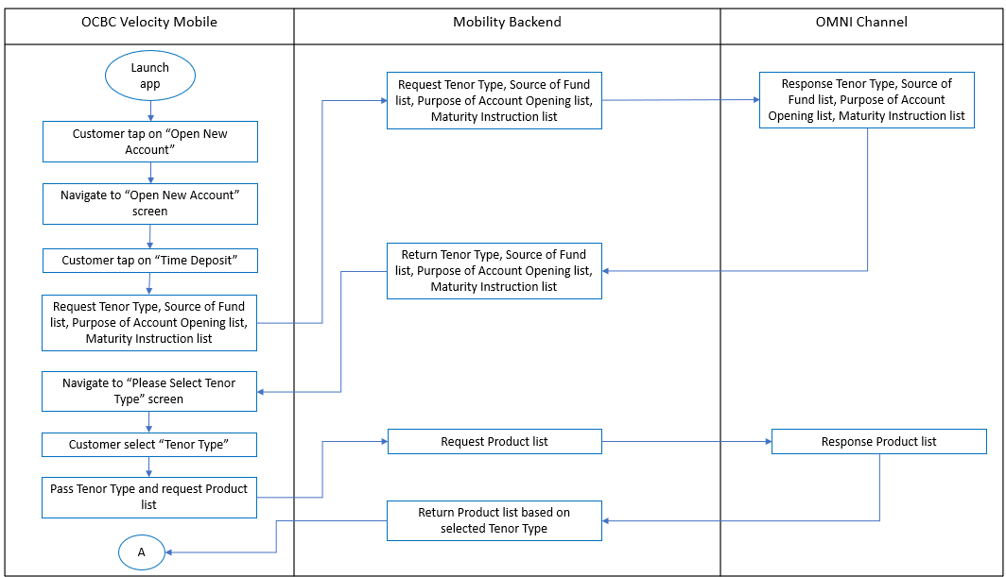

Figure 1 Time Deposit On Call (Day) Process Flow

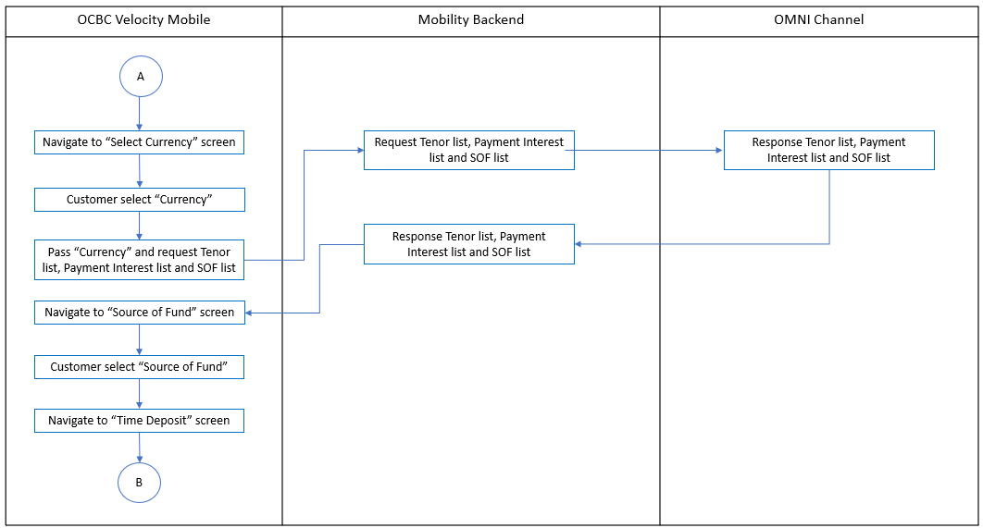

Figure 2 Time Deposit On Call (Day) Process Flow

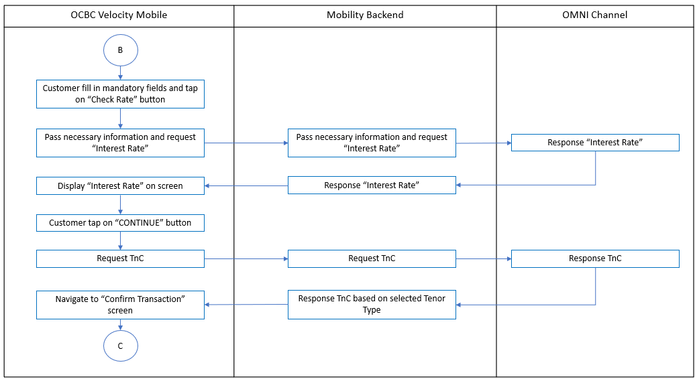

Figure 3 Time Deposit On Call (Day) Process Flow

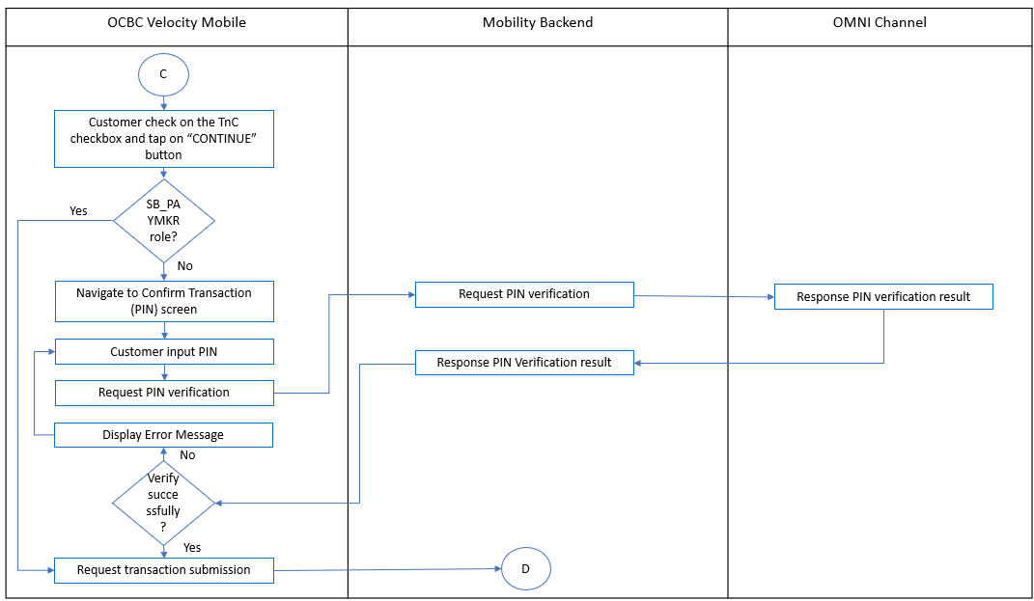

**Figure 4 Time Deposit On Call (Day) Process Flow**

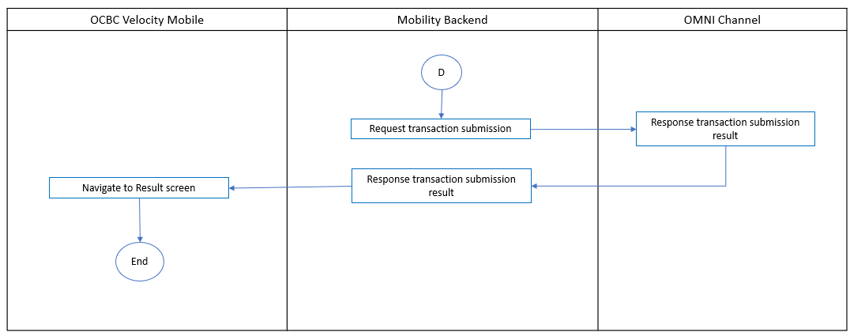

**Figure 5 Time Deposit On Call (Day) Process Flow**

* 1. **User Interface**

### Open Time Deposit On Call (Day) Account

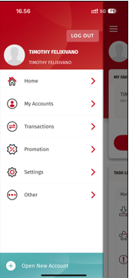

Figure 6 Open Time Deposit On Call (Day) - Access Point

|  |  |  |  |  |  |
| --- | --- | --- | --- | --- | --- |
| **No** | **Field Name** | **Data Type** | **M\*** | **Length** | **Remarks/ Validation** |
|  | Open New Account | Button | - |  | Navigate to Open New Account Screen |

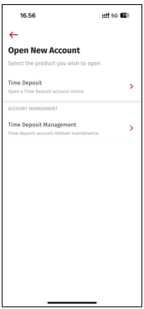

Figure 7 Open Time Deposit On Call (Day) - Open New Account Screen

|  |  |  |  |  |  |
| --- | --- | --- | --- | --- | --- |
| **No** | **Field Name** | **Data Type** | **M\*** | **Length** | **Remarks/ Validation** |
|  |  | Icon | - |  | Navigate to previous screen, Side Menu |
|  | Time Deposit | Button | - |  | Navigate to Tenor Type screen |
|  | Time Deposit Management | Button | - |  | Navigate to Time Deposit Management screen |

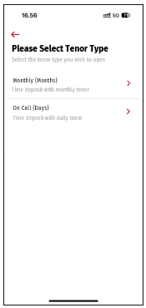

Figure 8 Open Time Deposit On Call (Day) - Tenor Type Screen

|  |  |  |  |  |  |
| --- | --- | --- | --- | --- | --- |
| **No** | **Field Name** | **Data Type** | **M\*** | **Length** | **Remarks/ Validation** |
|  |  | Icon | - |  | Navigate to previous screen, Open New Account screen |
|  | Monthly (Months) | Button | - |  | Navigate to Select Currency screen (monthly time deposit product) |
|  | On Call (Days) | Button | - |  | Navigate to Currency screen (on call time deposit product) |

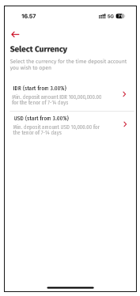

Figure 9 Open Time Deposit On Call (Day) - Currency (Product) Screen

|  |  |  |  |  |  |
| --- | --- | --- | --- | --- | --- |
| **No** | **Field Name** | **Data Type** | **M\*** | **Length** | **Remarks/ Validation** |
|  |  | Icon | - |  | Navigate to previous screen, Tenor Type screen |
|  | Currency Listing (Product) | Button | - |  | Navigate to Source of Fund screen |

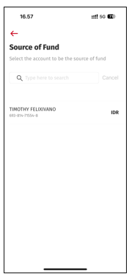

Figure 10 Open Time Deposit On Call (Day) - Source of Fund Listing Screen

|  |  |  |  |  |  |
| --- | --- | --- | --- | --- | --- |
| **No** | **Field Name** | **Data Type** | **M\*** | **Length** | **Remarks/ Validation** |
|  |  | Icon | - |  | Navigate to previous screen, Currency screen |
|  | Type here to search | Text Box | - |  |  |
|  | Source of Fund Listing | Button | - |  | Navigate to Time Deposit screen |

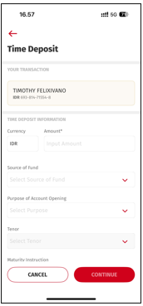 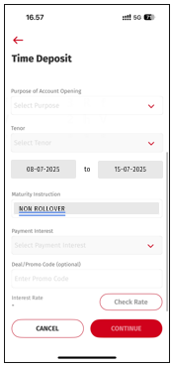

Figure 11 Open Time Deposit On Call (Day) - Time Deposit Screen

|  |  |  |  |  |  |
| --- | --- | --- | --- | --- | --- |
| **No** | **Field Name** | **Data Type** | **M\*** | **Length** | **Remarks/ Validation** |
|  |  | Icon | - |  | Navigate to previous screen, Source of Fund screen |
|  | Source of Fund Account Name | Label | - |  |  |
|  | Source of Fund Account Number | Label | - |  |  |
|  | Currency | Label | - |  |  |
|  | Amount | Text Box | M |  |  |
|  | Source of Fund | Dropdown | M |  |  |
|  | Purpose of Account Opening | Dropdown | M |  |  |
|  | Tenor | Dropdown | M |  | * Dropdown list option should be 7 Days, 8 Days, 9 Days, 10 Days, 11 Days, 12 Days, 13 Days, 14 Days. * Enabled when “Amount”, “Source of Fund” and “Purpose of Account Opening” fields are filled. |
|  | Period | Label | - |  | * + Will show when "Tenor" is selected and non-editable.   + The start date period always be today’s date.   + Weekends and public holidays should be included in the tenor.   + It is not impacted by cut off time. |
|  | Maturity Instruction | Dropdown | M |  | Only have 1 option which is "Non Rollover" and non-editable |
|  | Payment Interest | Dropdown | M |  | Enabled when “Amount”, “Source of Fund”, “Purpose of Account Opening” and “Tenor” fields are filled. |
|  | Deal / Promo Code (optional) | Text Box | - |  |  |
|  | Interest Rate | Label | - |  |  |
|  | Check Rate | Button | - |  |  |
|  | CANCEL | Button | - |  | Navigate to Home screen |
| 1. C | CONTINUE | Button | - |  | * Enabled when all mandatory fields are filled. * Navigate to Confirm Transaction screen |

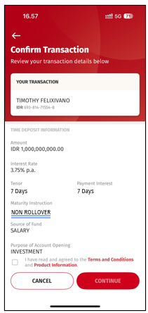

Figure 12 Open Time Deposit On Call (Day) - Confirm Transaction Screen

|  |  |  |  |  |  |
| --- | --- | --- | --- | --- | --- |
| **No** | **Field Name** | **Data Type** | **M\*** | **Length** | **Remarks/ Validation** |
|  |  | Icon | - |  | Navigate to previous screen, Time Deposit screen |
|  | Source of Fund Account Name | Label | - |  |  |
|  | Source of Fund Account Number | Label | - |  |  |
|  | Currency | Label | - |  |  |
|  | Amount | Label | - |  |  |
|  | Interest Rate | Label | - |  |  |
|  | Tenor | Label | - |  | Value show in Days |
|  | Payment Interest | Label | - |  | Value show in Days |
|  | Maturity Instruction | Label | - |  |  |
|  | Source of Fund | Label | - |  |  |
|  | Purpose of Account Opening | Label | - |  |  |
| 1. \ | I have read and agreed to the Terms and Conditions and Product Info | Check Box | M |  |  |
|  | Terms and Conditions | Link | - |  | Open Terms & Conditions PDF |
|  | Production Information | Link | - |  | Open Product Information PDF |
|  | CANCEL | Button | - |  | Navigate to Home screen |
| 1. C | CONTINUE | Button | - |  | * Enabled when all mandatory fields are filled. * Navigate to Confirm Transaction (PIN) screen |

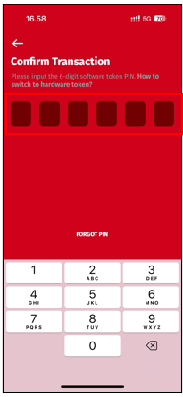

Figure 13 Open Time Deposit On Call (Day) - Confirm Transaction (PIN) Screen

|  |  |  |  |  |  |
| --- | --- | --- | --- | --- | --- |
| **No** | **Field Name** | **Data Type** | **M\*** | **Length** | **Remarks/ Validation** |
|  |  | Icon | - |  | Navigate to previous screen, Confirm Transaction screen |
|  | 6-digit token PIN | Numeric Field | - |  |  |

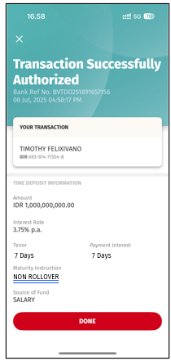

Figure 14 Open Time Deposit On Call (Day) - Transaction Receipt Screen

|  |  |  |  |  |  |
| --- | --- | --- | --- | --- | --- |
| **No** | **Field Name** | **Data Type** | **M\*** | **Length** | **Remarks/ Validation** |
|  |  | Icon | - |  | Navigate to Home screen |
|  | Source of Fund Account Name | Label | - |  |  |
|  | Source of Fund Account Number | Label | - |  |  |
|  | Currency | Label | - |  |  |
|  | Amount | Label | - |  |  |
|  | Interest Rate | Label | - |  |  |
|  | Tenor | Label | - |  |  |
|  | Payment Interest | Label | - |  |  |
|  | Maturity Instruction | Label | - |  |  |
|  | Source of Fund | Label | - |  |  |
|  | Purpose of Account Opening | Label | - |  |  |
| 1. C | DONE | Button | - |  | Navigate to Home screen |

### Account Summary

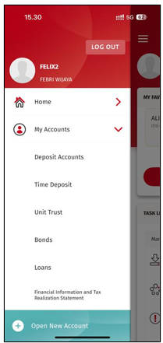

Figure 15 Account Summary – Time Deposit Access Point

|  |  |  |  |  |  |
| --- | --- | --- | --- | --- | --- |
| **No** | **Field Name** | **Data Type** | **M\*** | **Length** | **Remarks/ Validation** |
|  | Time Deposit | Button | - |  | Navigate to My Time Deposit screen |

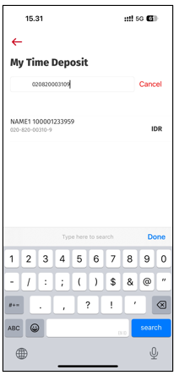

Figure 16 Account Summary – My Time Deposit Screen

|  |  |  |  |  |  |
| --- | --- | --- | --- | --- | --- |
| **No** | **Field Name** | **Data Type** | **M\*** | **Length** | **Remarks/ Validation** |
|  |  | Icon | - |  | Navigate to previous screen, Side Menu |
|  | Time Deposit Account Listing | Button | - |  | Navigate to Time Deposit details screen |

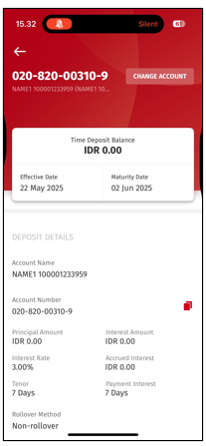

Figure 17 Account Summary – Time Deposit Details Screen

|  |  |  |  |  |  |
| --- | --- | --- | --- | --- | --- |
| **No** | **Field Name** | **Data Type** | **M\*** | **Length** | **Remarks/ Validation** |
|  |  | Icon | - |  | Navigate to previous screen, My Time Deposit screen |
|  | Account Number | Label | - |  |  |
|  | Account Name | Label | - |  |  |
|  | CHANGE ACCOUNT | Button | - |  |  |
|  | Time Deposit Balance | Label | - |  |  |
|  | Time Deposit Effective Date | Label | - |  |  |
|  | Maturity Date | Label | - |  |  |
|  | Account Name | Label | - |  |  |
|  | Account Number | Label | - |  |  |
|  | Principal Amount | Label | - |  |  |
|  | Interest Amount | Label | - |  |  |
|  | Interest Rate | Label | - |  |  |
|  | Accrued Interest | Label | - |  |  |
|  | Tenor | Label | - |  | Value show in Days |
|  | Payment Interest | Label | - |  | Value show in Days |
|  | Maturity Instruction | Label | - |  |  |

### Authorization

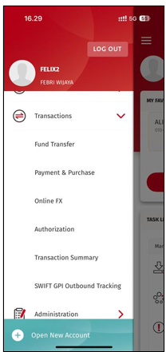

Figure 18 Authorization – Access Point

|  |  |  |  |  |  |
| --- | --- | --- | --- | --- | --- |
| **No** | **Field Name** | **Data Type** | **M\*** | **Length** | **Remarks/ Validation** |
|  | Authorization | Button | - |  | Navigate to Authorization screen |

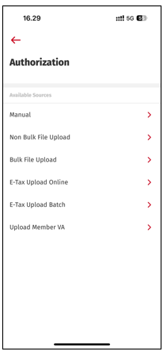

Figure 19 Authorization – Authorization Screen

|  |  |  |  |  |  |
| --- | --- | --- | --- | --- | --- |
| **No** | **Field Name** | **Data Type** | **M\*** | **Length** | **Remarks/ Validation** |
|  |  | Button | - |  | Navigate to previous screen, side menu |
|  | Manual | Button | - |  |  |
|  | Non Bulk File Upload | Button | - |  |  |
|  | Bulk File Upload | Button | - |  |  |
|  | E-Tax Upload Online | Button | - |  |  |
|  | E-Tax Upload Batch | Button | - |  |  |

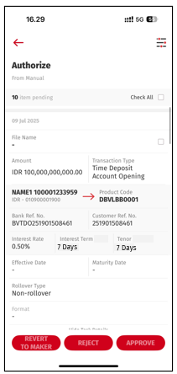

Figure 20 Authorization – Authorize (Manual) Screen

|  |  |  |  |  |  |
| --- | --- | --- | --- | --- | --- |
| **No** | **Field Name** | **Data Type** | **M\*** | **Length** | **Remarks/ Validation** |
|  |  | Button | - |  | Navigate to previous screen, side menu |
|  |  | Button | - |  |  |
|  | Number of Pending Items | Label | - |  |  |
|  | Check All | Check Box | - |  |  |
|  | Transaction Date | Label | - |  |  |
|  | File Name | Label | - |  |  |
|  | Transaction Check Box | Check Box | - |  |  |
| 1. \ | Amount | Label | - |  |  |
|  | Transaction Type | Label | - |  |  |
|  | Account Name | Label | - |  |  |
| 1. A | Account Currency | Label | - |  |  |
|  | Account Number | Label | - |  |  |
|  | Product Code | Label | - |  |  |
|  | Bank Ref No. | Label | - |  |  |
|  | Customer Ref No. | Label | - |  |  |
|  | Interest Rate | Label | - |  |  |
|  | Interest Term | Label | - |  | Label remove (M), Label show in Days |
|  | Tenor | Label | - |  | Label remove (M), Label show in Days |
| 1. E | Effective Date | Label | - |  |  |
|  | Maturity Date | Label | - |  |  |
|  | Rollover Type | Label | - |  |  |
|  | Format | Label | - |  |  |
|  | REVERT TO MAKER | Button | - |  |  |
|  | REJECT | Button | - |  |  |
|  | APPROVE | Button | - |  |  |



Figure 21 Authorization – Authorize Approve (Manual) Screen

|  |  |  |  |  |  |
| --- | --- | --- | --- | --- | --- |
| **No** | **Field Name** | **Data Type** | **M\*** | **Length** | **Remarks/ Validation** |
|  |  | Button | - |  | Navigate to previous screen, Authorize (Manual) screen |
|  |  | Button | - |  |  |
|  | Transaction Date | Label | - |  |  |
|  | File Name | Label | - |  |  |
| 1. \ | Amount | Label | - |  |  |
|  | Transaction Type | Label | - |  |  |
|  | Account Name | Label | - |  |  |
| 1. A | Account Currency | Label | - |  |  |
|  | Account Number | Label | - |  |  |
|  | Product Code | Label | - |  |  |
|  | Bank Ref No. | Label | - |  |  |
|  | Customer Ref No. | Label | - |  |  |
|  | Interest Rate | Label | - |  |  |
|  | Interest Term | Label | - |  | Label remove (M), Label show in Days |
|  | Tenor | Label | - |  | Label remove (M), Label show in Days |
| 1. E | Effective Date | Label | - |  |  |
|  | Maturity Date | Label | - |  |  |
|  | Rollover Type | Label | - |  |  |
|  | Format | Label | - |  |  |
|  | Total Items | Label | - |  |  |
|  | VIEW DETAILS | Button | - |  |  |
|  | OK | Button | - |  |  |

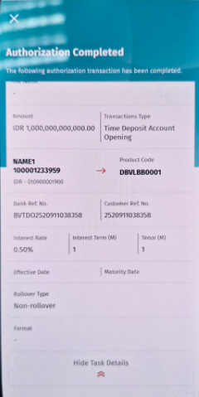

Figure 22 Authorization – Authorize Approve (Manual) Screen

|  |  |  |  |  |  |
| --- | --- | --- | --- | --- | --- |
| **No** | **Field Name** | **Data Type** | **M\*** | **Length** | **Remarks/ Validation** |
|  | File Name | Label | - |  |  |
| 1. \ | Amount | Label | - |  |  |
|  | Transaction Type | Label | - |  |  |
|  | Account Name | Label | - |  |  |
| 1. A | Account Currency | Label | - |  |  |
|  | Account Number | Label | - |  |  |
|  | Product Code | Label | - |  |  |
|  | Bank Ref No. | Label | - |  |  |
|  | Customer Ref No. | Label | - |  |  |
|  | Interest Rate | Label | - |  |  |
|  | Interest Term | Label | - |  | Label remove (M), Label show in Days |
|  | Tenor | Label | - |  | Label remove (M), Label show in Days |
| 1. E | Effective Date | Label | - |  |  |
|  | Maturity Date | Label | - |  |  |
|  | Rollover Type | Label | - |  |  |
|  | Format | Label | - |  |  |

### Task List

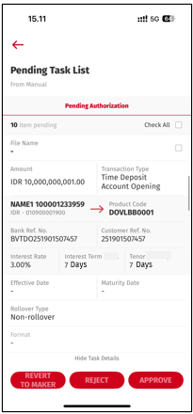

Figure 23 Task List – Pending Task List Screen

|  |  |  |  |  |  |
| --- | --- | --- | --- | --- | --- |
| **No** | **Field Name** | **Data Type** | **M\*** | **Length** | **Remarks/ Validation** |
|  |  | Button | - |  | Navigate to previous screen, home screen |
|  | Number of Pending Items | Label | - |  |  |
|  | Check All | Check Box | - |  |  |
|  | Transaction Date | Label | - |  |  |
|  | File Name | Label | - |  |  |
|  | Transaction Check Box | Check Box | - |  |  |
| 1. \ | Amount | Label | - |  |  |
|  | Transaction Type | Label | - |  |  |
|  | Account Name | Label | - |  |  |
| 1. A | Account Currency | Label | - |  |  |
|  | Account Number | Label | - |  |  |
|  | Product Code | Label | - |  |  |
|  | Bank Ref No. | Label | - |  |  |
|  | Customer Ref No. | Label | - |  |  |
|  | Interest Rate | Label | - |  |  |
|  | Interest Term | Label | - |  | Label remove (M), Label show in Days |
|  | Tenor | Label | - |  | Label remove (M), Label show in Days |
| 1. E | Effective Date | Label | - |  |  |
|  | Maturity Date | Label | - |  |  |
|  | Rollover Type | Label | - |  |  |
|  | Format | Label | - |  |  |
|  | REVERT TO MAKER | Button | - |  |  |
|  | REJECT | Button | - |  |  |
|  | APPROVE | Button | - |  |  |

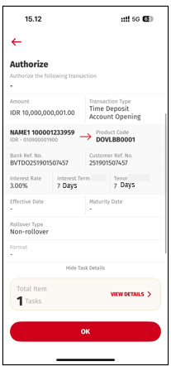

Figure 24 Task List – Authorize Approve (Manual) Screen

|  |  |  |  |  |  |
| --- | --- | --- | --- | --- | --- |
| **No** | **Field Name** | **Data Type** | **M\*** | **Length** | **Remarks/ Validation** |
|  |  | Button | - |  | Navigate to previous screen, Authorize (Manual) screen |
|  |  | Button | - |  |  |
|  | Transaction Date | Label | - |  |  |
|  | File Name | Label | - |  |  |
| 1. \ | Amount | Label | - |  |  |
|  | Transaction Type | Label | - |  |  |
|  | Account Name | Label | - |  |  |
| 1. A | Account Currency | Label | - |  |  |
|  | Account Number | Label | - |  |  |
|  | Product Code | Label | - |  |  |
|  | Bank Ref No. | Label | - |  |  |
|  | Customer Ref No. | Label | - |  |  |
|  | Interest Rate | Label | - |  |  |
|  | Interest Term | Label | - |  | Label remove (M), Label show in Days |
|  | Tenor | Label | - |  | Label remove (M), Label show in Days |
| 1. E | Effective Date | Label | - |  |  |
|  | Maturity Date | Label | - |  |  |
|  | Rollover Type | Label | - |  |  |
|  | Format | Label | - |  |  |
|  | Total Items | Label | - |  |  |
|  | VIEW DETAILS | Button | - |  |  |
|  | OK | Button | - |  |  |

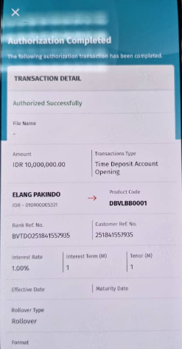

Figure 25 Authorization – Authorize Approve (Manual) Screen

|  |  |  |  |  |  |
| --- | --- | --- | --- | --- | --- |
| **No** | **Field Name** | **Data Type** | **M\*** | **Length** | **Remarks/ Validation** |
|  | File Name | Label | - |  |  |
| 1. \ | Amount | Label | - |  |  |
|  | Transaction Type | Label | - |  |  |
|  | Account Name | Label | - |  |  |
| 1. A | Account Currency | Label | - |  |  |
|  | Account Number | Label | - |  |  |
|  | Product Code | Label | - |  |  |
|  | Bank Ref No. | Label | - |  |  |
|  | Customer Ref No. | Label | - |  |  |
|  | Interest Rate | Label | - |  |  |
|  | Interest Term | Label | - |  | Label remove (M), Label show in Days |
|  | Tenor | Label | - |  | Label remove (M), Label show in Days |
| 1. E | Effective Date | Label | - |  |  |
|  | Maturity Date | Label | - |  |  |
|  | Rollover Type | Label | - |  |  |
|  | Format | Label | - |  |  |

### Transaction Summary

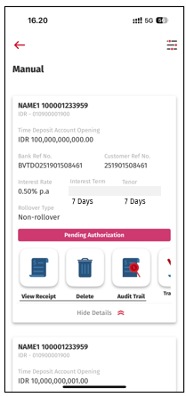

Figure 26 Transaction Summary – Manual Transaction Screen

|  |  |  |  |  |  |
| --- | --- | --- | --- | --- | --- |
| **No** | **Field Name** | **Data Type** | **M\*** | **Length** | **Remarks/ Validation** |
|  |  | Button | - |  | Navigate to previous screen, Transaction Summary Available Source screen |
|  |  | Button | - |  |  |
|  | Account Name | Label | - |  |  |
|  | Account Currency | Label | - |  |  |
|  | Account Number | Label | - |  |  |
|  | Amount | Label | - |  |  |
| 1. \ | Bank Ref No. | Label | - |  |  |
|  | Customer Ref No. | Label | - |  |  |
|  | Interest Rate | Label | - |  |  |
| 1. A | Interest Term | Label | - |  | Label remove (M), Label show in Days |
|  | Tenor | Label | - |  | Label remove (M), Label show in Days |
|  | Rollover Type | Label | - |  |  |
|  | Transaction Status | Label | - |  |  |
|  | View Receipt | Button | - |  |  |
|  | Delete | Button | - |  |  |
|  | Audit Trail | Button | - |  |  |
|  | Transaction Notes | Button | - |  |  |

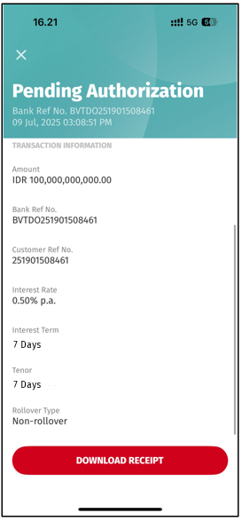

Figure 27 Transaction Summary – Receipt Screen

|  |  |  |  |  |  |
| --- | --- | --- | --- | --- | --- |
| **No** | **Field Name** | **Data Type** | **M\*** | **Length** | **Remarks/ Validation** |
|  | Bank Ref No. | Label | - |  |  |
|  | Transaction Date and Time | Label | - |  |  |
|  | Amount | Label | - |  |  |
|  | Bank Ref No. | Label | - |  |  |
|  | Customer Ref No. | Label | - |  |  |
|  | Interest Rate | Label | - |  |  |
| 1. \ | Interest Term | Label | - |  | Label remove (M), Label show in Days |
|  | Tenor | Label | - |  | Label remove (M), Label show in Days |
|  | Rollover Type | Label | - |  |  |
|  | DOWNLOAD RECEIPT | Button | - |  |  |