OCBC Velocity Regain Access Information

Functional Specifications Document

Velocity Mobile Banking

**Confidentiality**

This document contains proprietary information that is confidential to OCBC NISP. Disclosure of this document in full or in part, may result in material damage to OCBC NISP. Written permission must be obtained from OCBC NISP prior to the disclosure of this document to third party.

PREFACE

***Purpose***

This Functional Specification Document (FSD) describes Velocity Mobile Banking features and system flow.

This document will form the final requirements for the development activities such as design, customization, and testing and implementation of Velocity Mobile Bankingfeatures and system flow.

***Document Change Control***

|  |  |  |  |
| --- | --- | --- | --- |
| **Version** | **Date** | **Authors** | **Summary of Changes** |
| 0.1 | 2nd September 2025 | Yap Chek Ying |  |
|  |  |  |  |
|  |  |  |  |
|  |  |  |  |
|  |  |  |  |

***Reference Document***

|  |  |  |
| --- | --- | --- |
| **No** | **Document Name** | **Authors** |
| 1 |  |  |
|  |  |  |

***Table of Contents***

1 Introduction 3

**1.1** **Supported Devices & OS Version** 3

2 Functional Specification 4

**2.1** **Regain Access Information** 4

2.1.1 General Description of Functionality 4

**2.2** **Process Flow for Regain Access Information** 5

**2.3** **User Interface** 5

***Table of Figures***

Figure 1 Block My User Screen 5

# Introduction

This Functional Specification Document has been setup with the objective of enhancing Velocity Mobile (hereinafter to be referred as “VM”) to update the information for 'Regain Access' on the 'Block My User' screen.

More details and processes with screen designs are shown in this document.

* 1. **Supported Devices & OS Version**

The VM App will be supported on the following Mobile OS:-

| **Mobile OS** | **Remarks** |
| --- | --- |
| Android | 5 and above |
| iOS | 12.4 and above |

***\*Jail broken / rooted devices are not Supported.***

*Note: All screen designs shown in this document is for illustration purpose only. Screen design may differ during the development phase.*

# Functional Specification

* 1. **Regain Access Information**

1. Display the updated information for 'Regain Access' on the 'Block My User' screen:

* **EN:**

Regain Access

To regain access, please email [clientservices@ocbc.id](mailto:clientservices@ocbc.id).

For any inquiries, you may contact TANYA OCBC at 1500-999/+62-21-26506300 (from overseas) and choose Business Banking Customer.

* **ID:**

Mengembalikan akses  
Untuk mengembalikan akses, mohon email ke [clientservices@ocbc.id](mailto:clientservices@ocbc.id).

Jika ada pertanyaan, silakan hubungi TANYA OCBC di 1500-999/+62-21-26506300 (dari luar negeri) dan pilih Nasabah Bisnis.

* **CN:**

重新获取访问权限

如需重新获取访问权限，[请发送邮件至clientservices@ocbc.id](mailto:请发送邮件至clientservices@ocbc.id).

如有任何疑问，您可以联系TANYA OCBC， 拨打1500-999或+6221-26506300（海外拨打），并选择企业银行客户 (Business Banking Customer).

### General Description of Functionality

N/A

* 1. **Process Flow for Regain Access Information**

N/A

* 1. **User Interface**

Display the updated information for 'Regain Access' on the 'Block My User' screen.

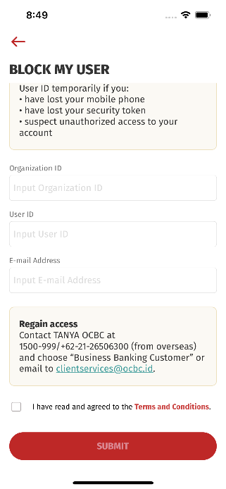

Figure 1 Block My User Screen

|  |  |  |  |  |  |
| --- | --- | --- | --- | --- | --- |
| **No** | **Field Name** | **Data Type** | **M\*** | **Length** | **Remarks/ Validation** |
|  | - | - | - | - | - |